Design

## Wireframe

**Log in page**

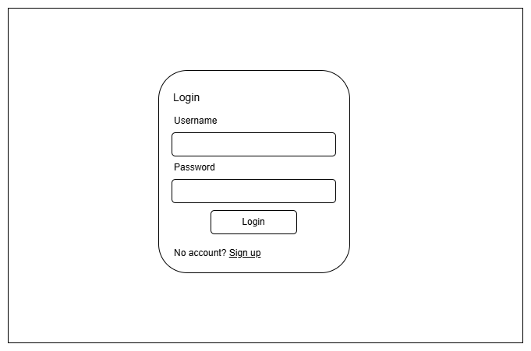

Figure 3.1 1: Wireframe for Log In Page

**Sign up page**

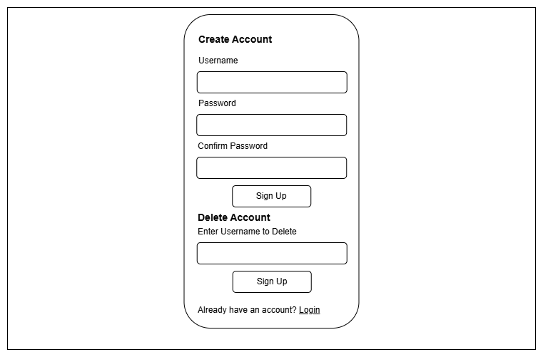

Figure 3.1 2: Wireframe for Sign Up Page

**Log out page**

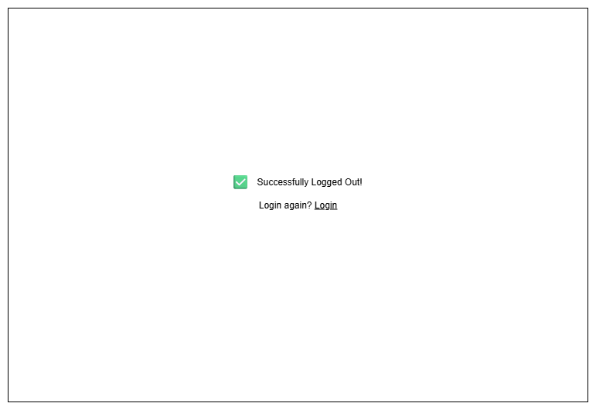

Figure 3.1 3: Wireframe for Log Out Page

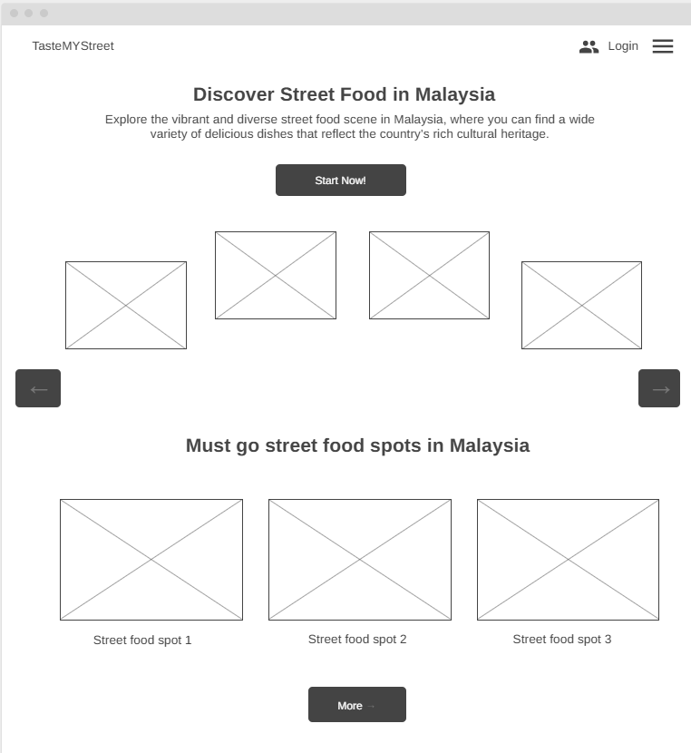**Home Page (index.html)**

Figure 3.1 4: Wireframe for Home Page (1)

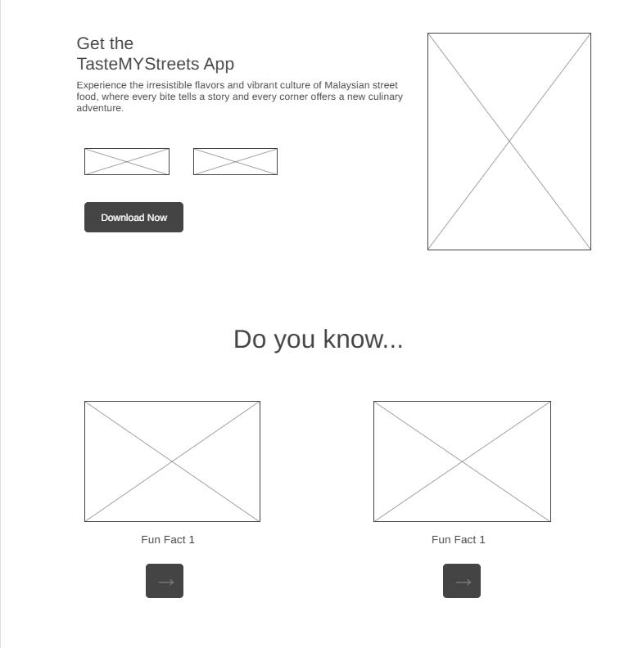

Figure 3.1.4. 1: Wireframe for Home Page (2)

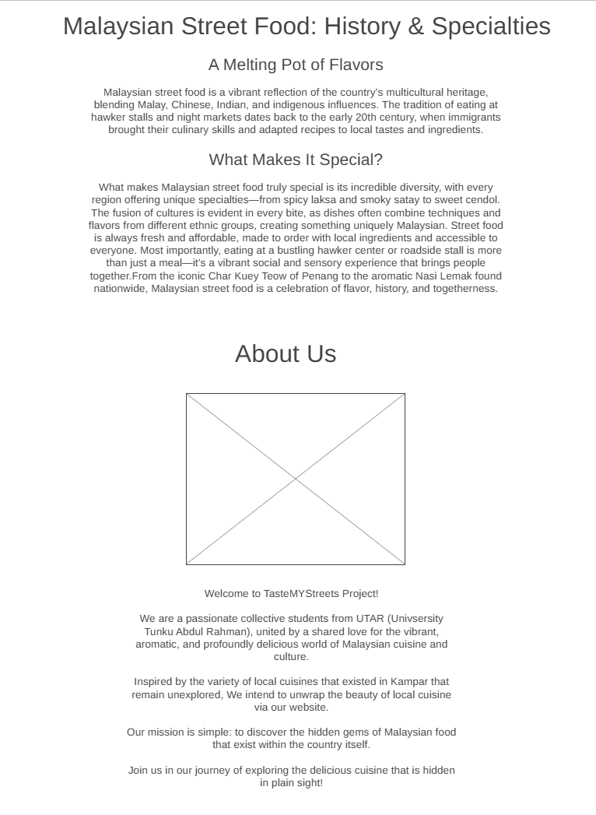

Figure 3.1.4. 2: Wireframe for Home Page (3)

**Contact us page (contact.html)**

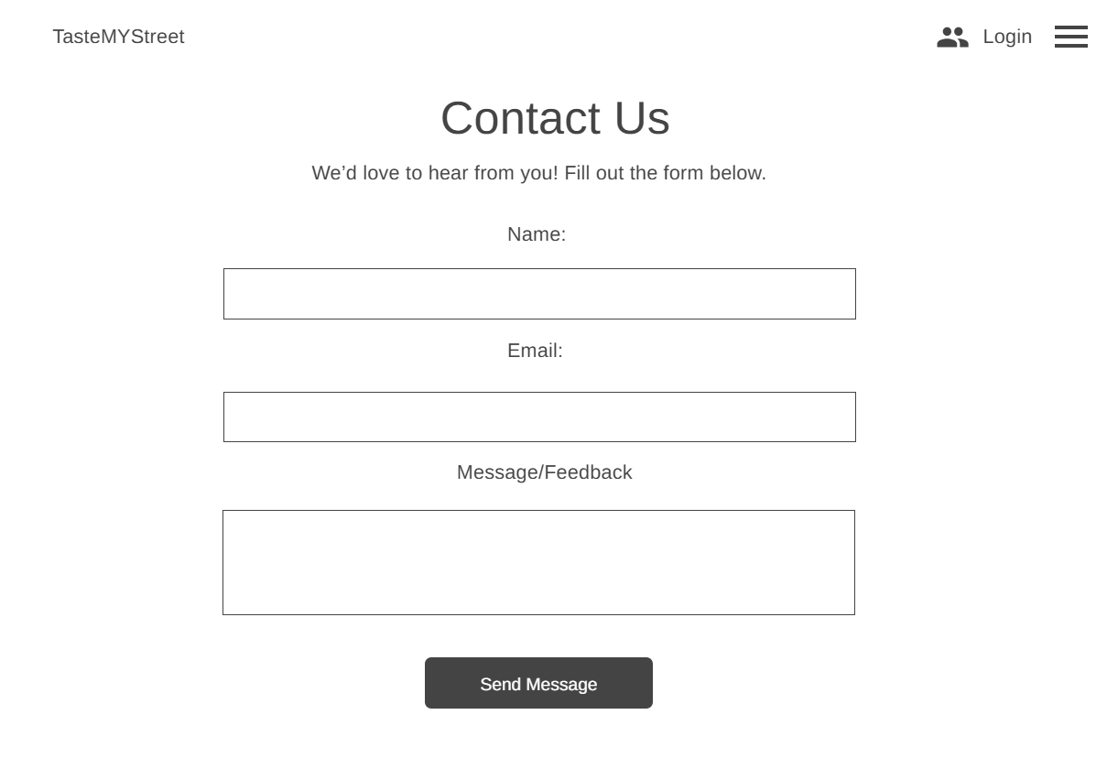

Figure 3.1 5: Wireframe for Contact Page

**Discover page(discover.html)**

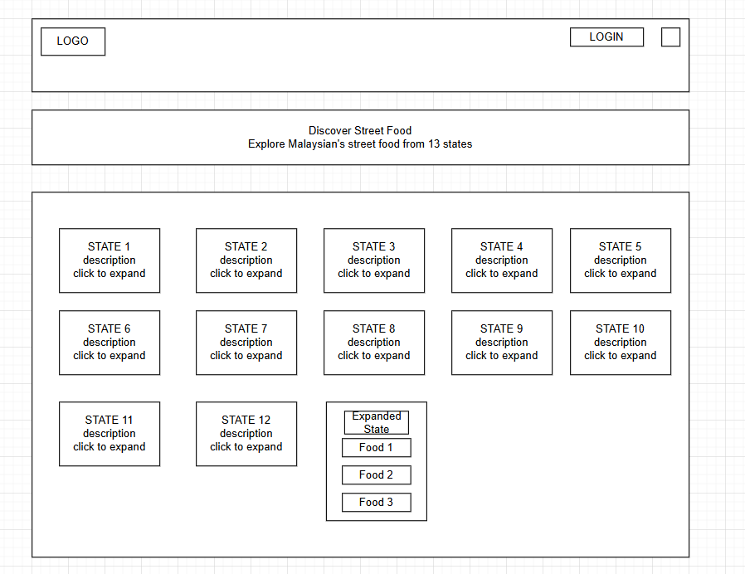

Figure 3.1 6: Wireframe for Discover Page

**Ranking Page (rank.html)**

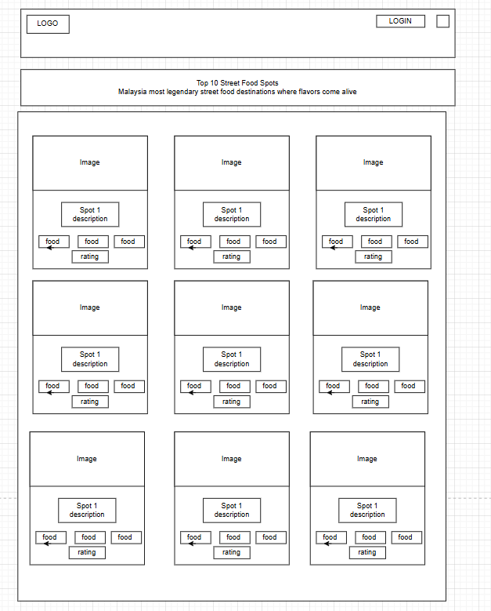

Figure 3.1 7: Wireframe for Ranking Page

**About Page (about.html)**

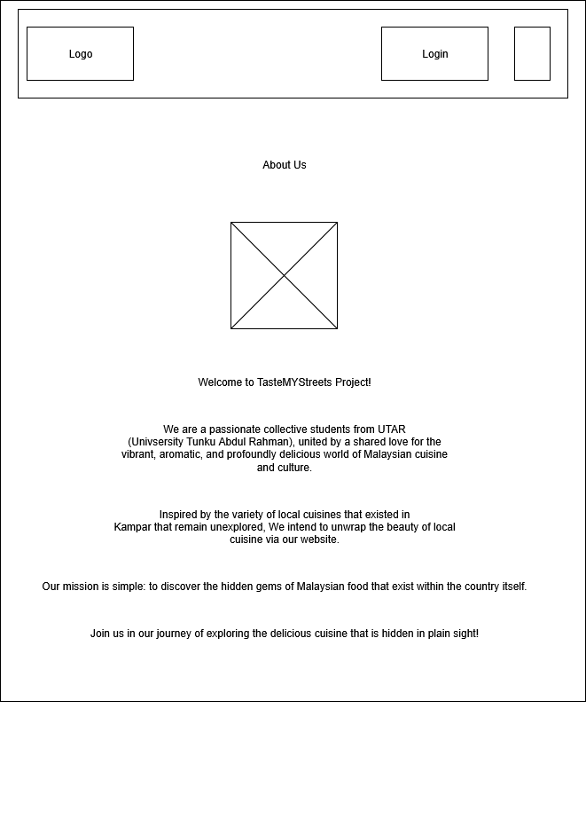

Figure 3.1 8: Wireframe for About Page

**Quiz Page (quiz.html)**

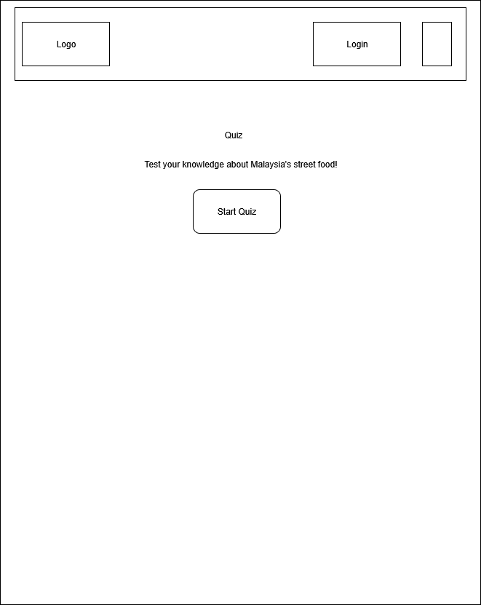

Figure 3.1.9. 1: Wireframe for Quiz Page

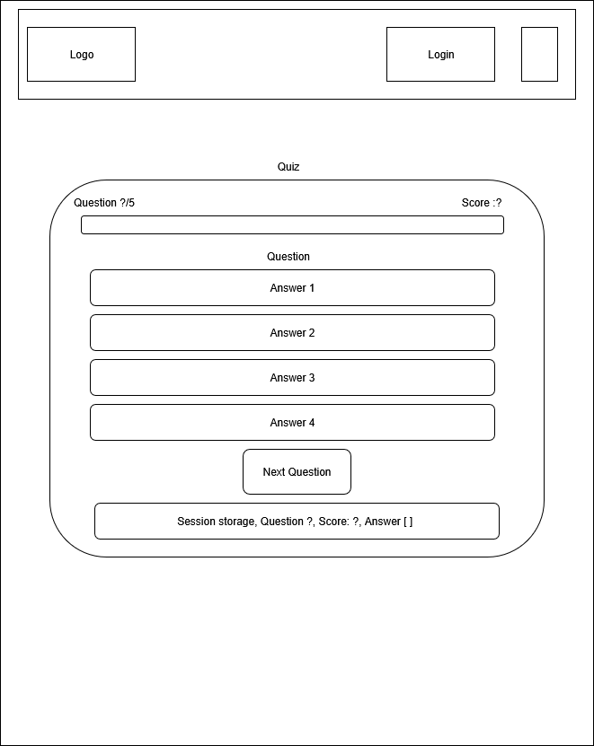

Figure 3.1.9. 2: Wireframe for Quiz Page (2)

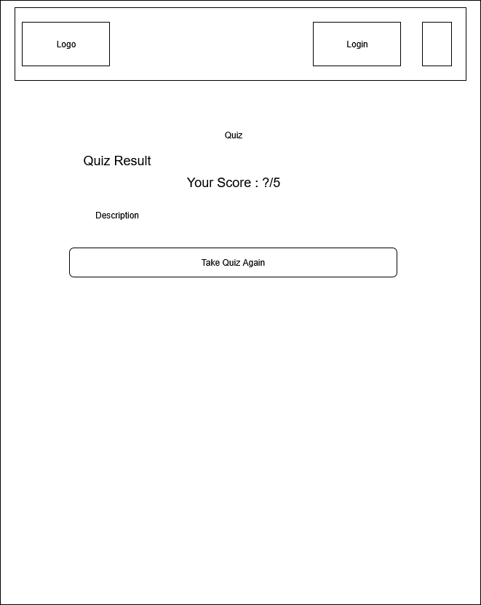

Figure 3.1.9. 3: Wireframe for Quiz Page (3)

## Page Mock Up

**Log in (login.html)**

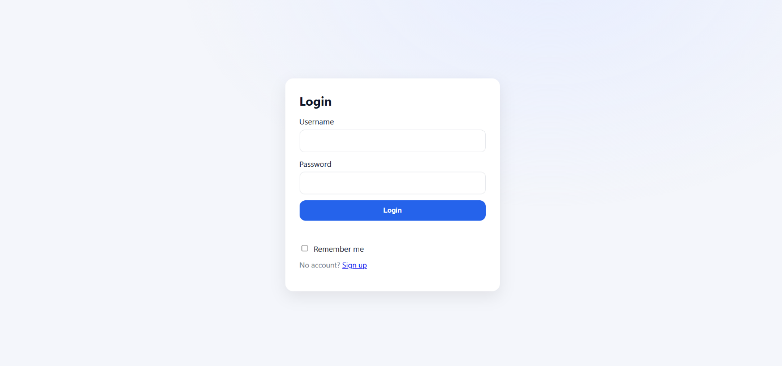

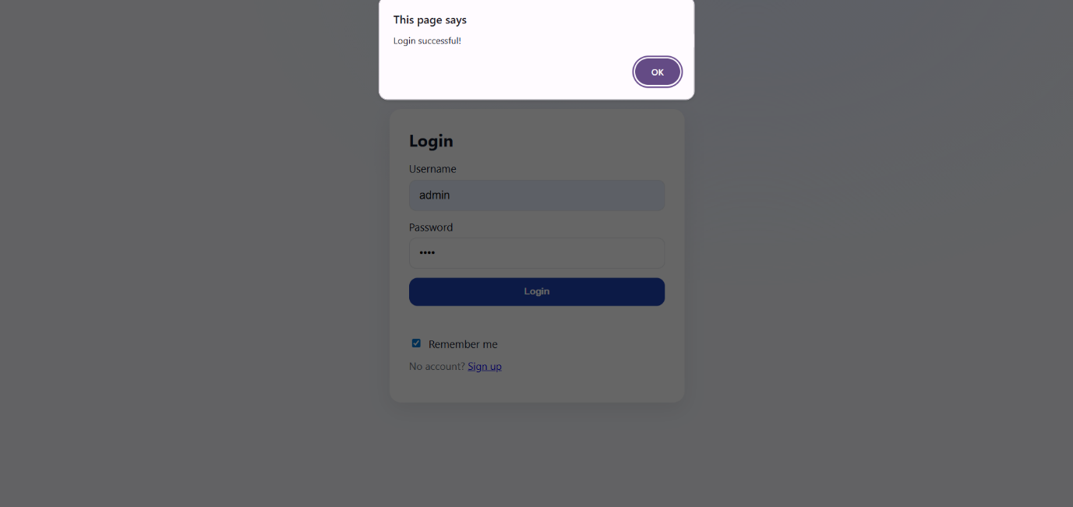

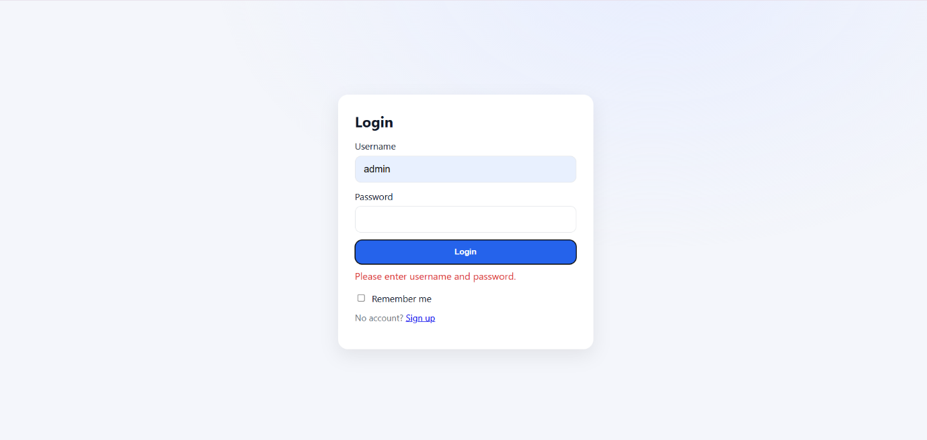

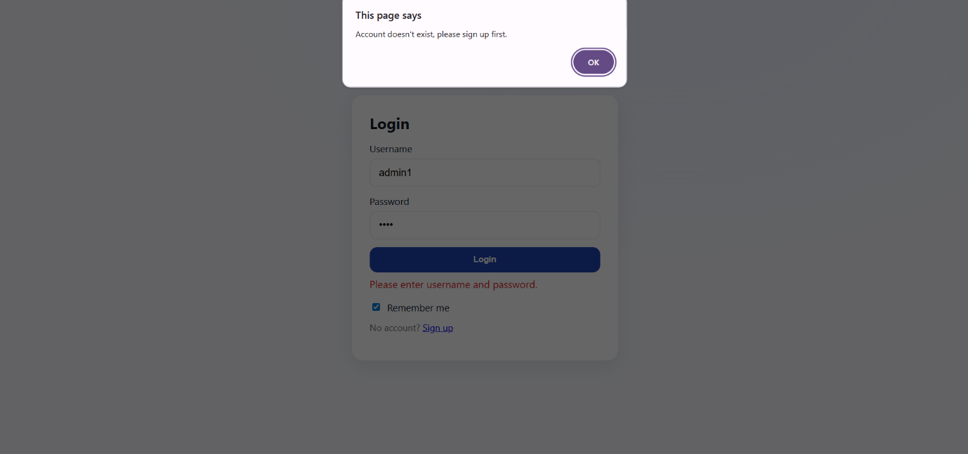

**Sign up & delete account page (signup.html)**

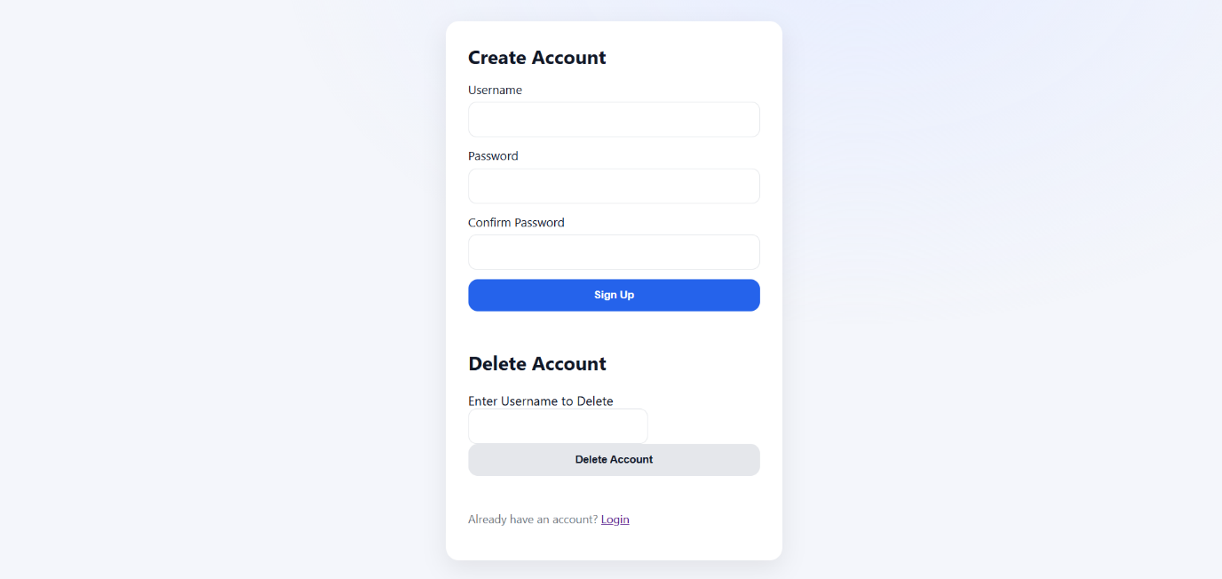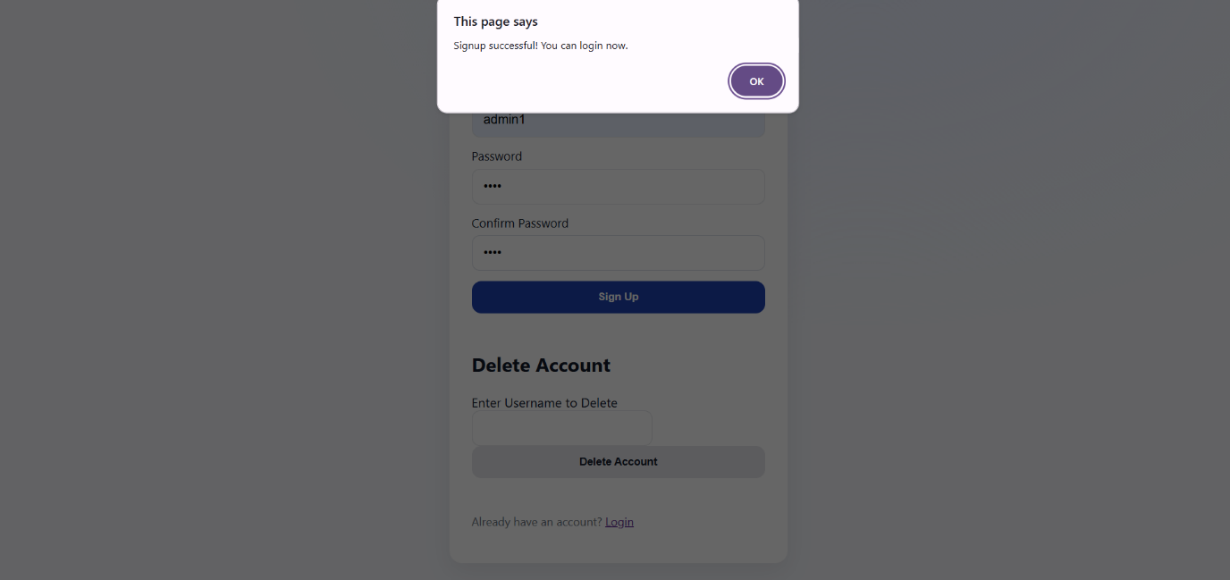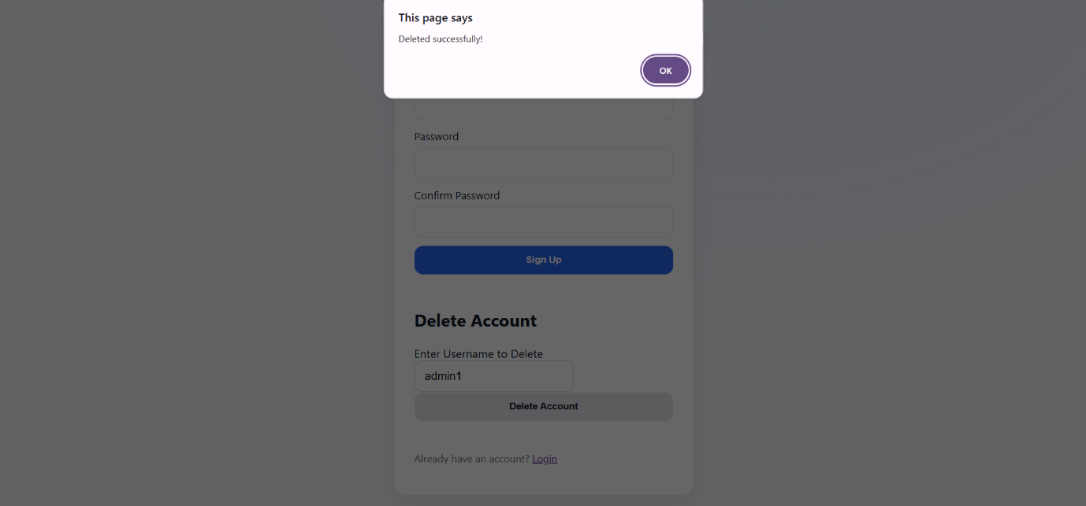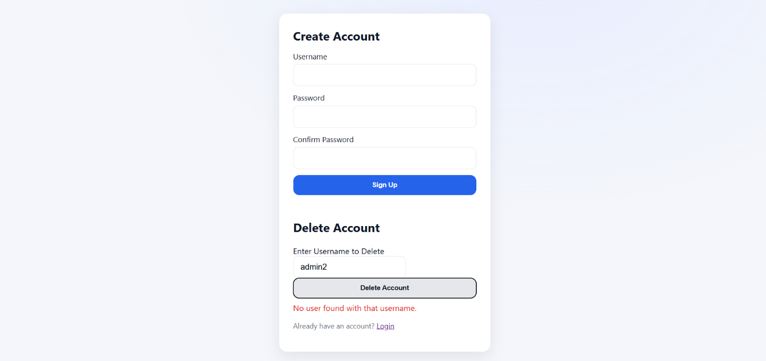

**Log out page (logout.html)**

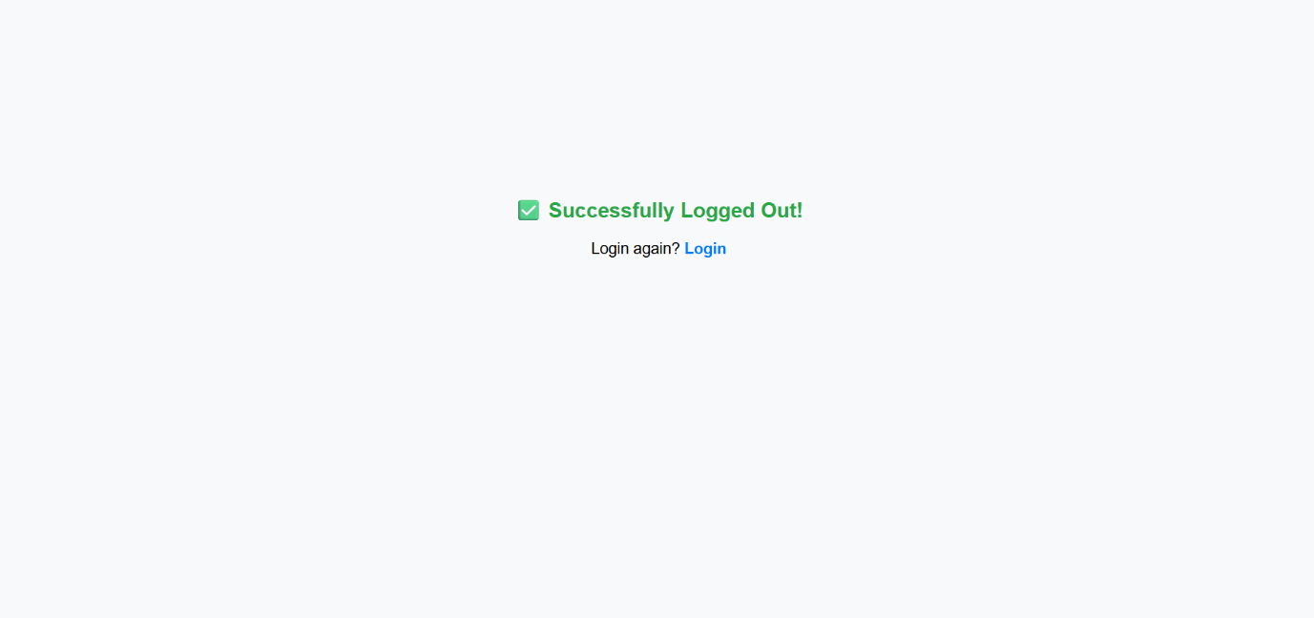

**Homepage(index.html)**

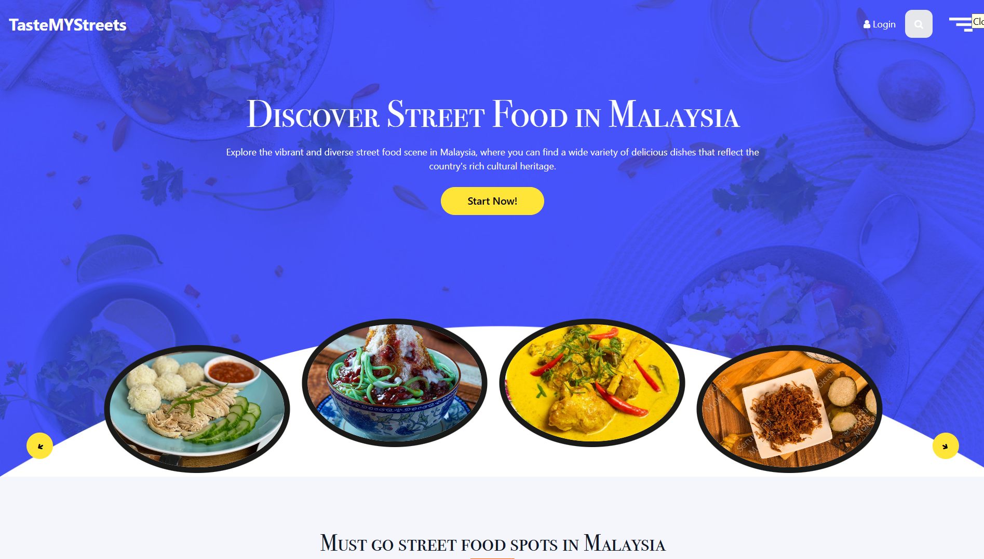

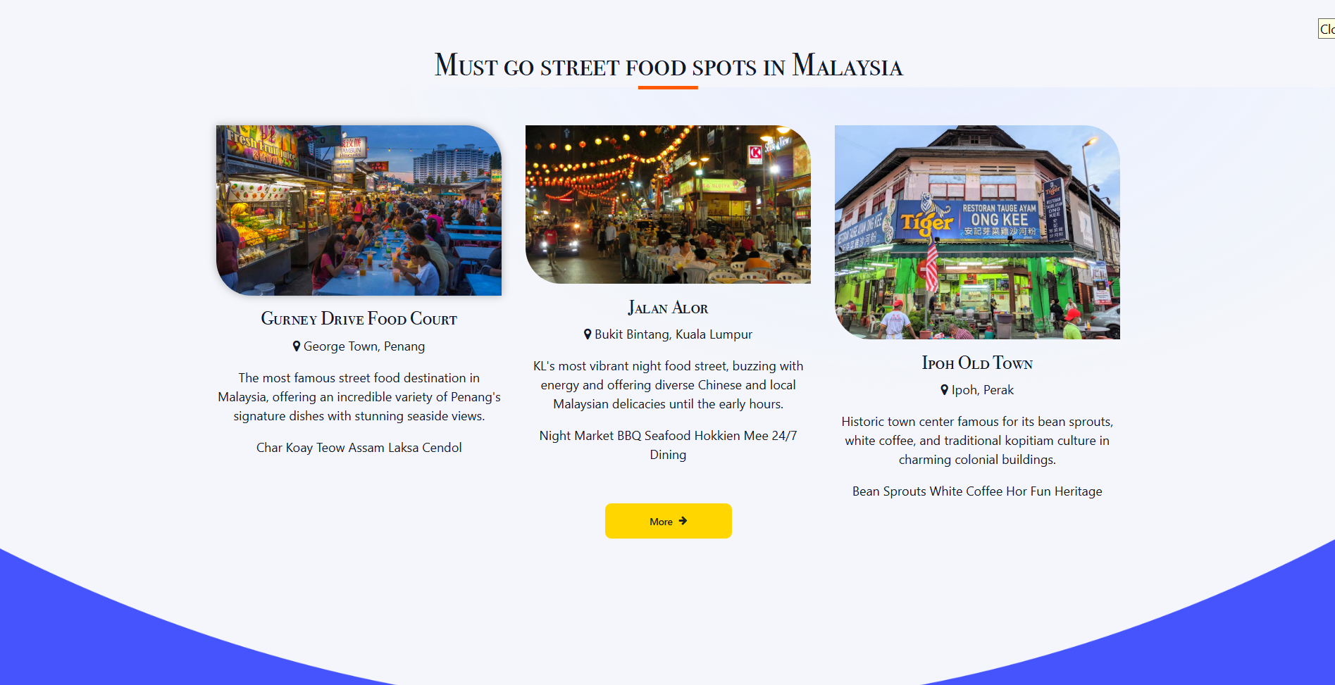

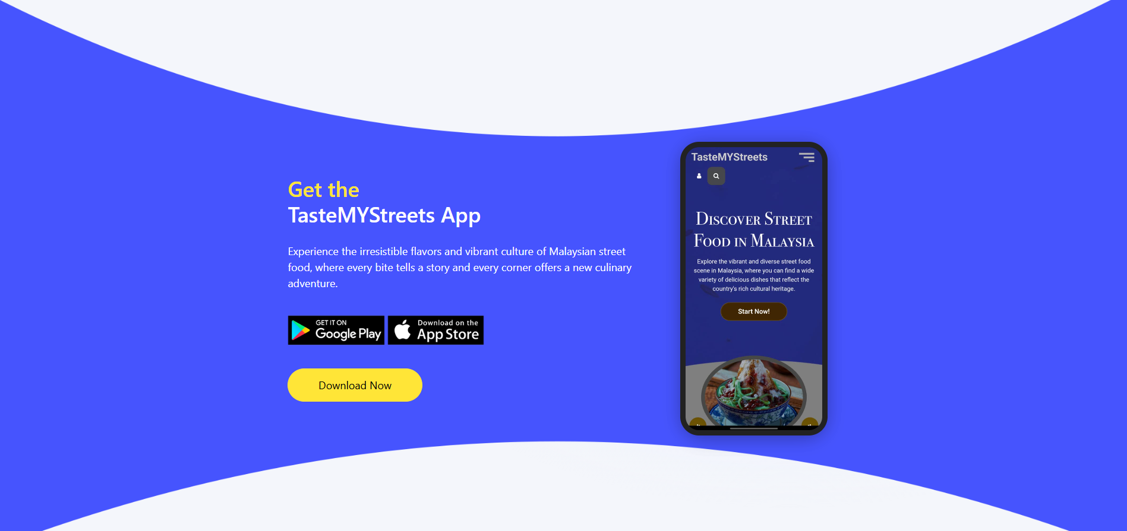

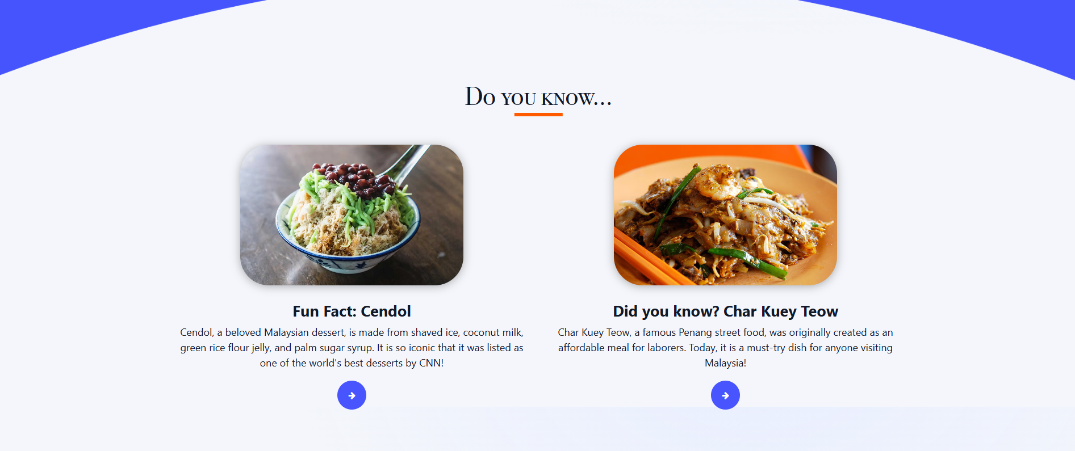



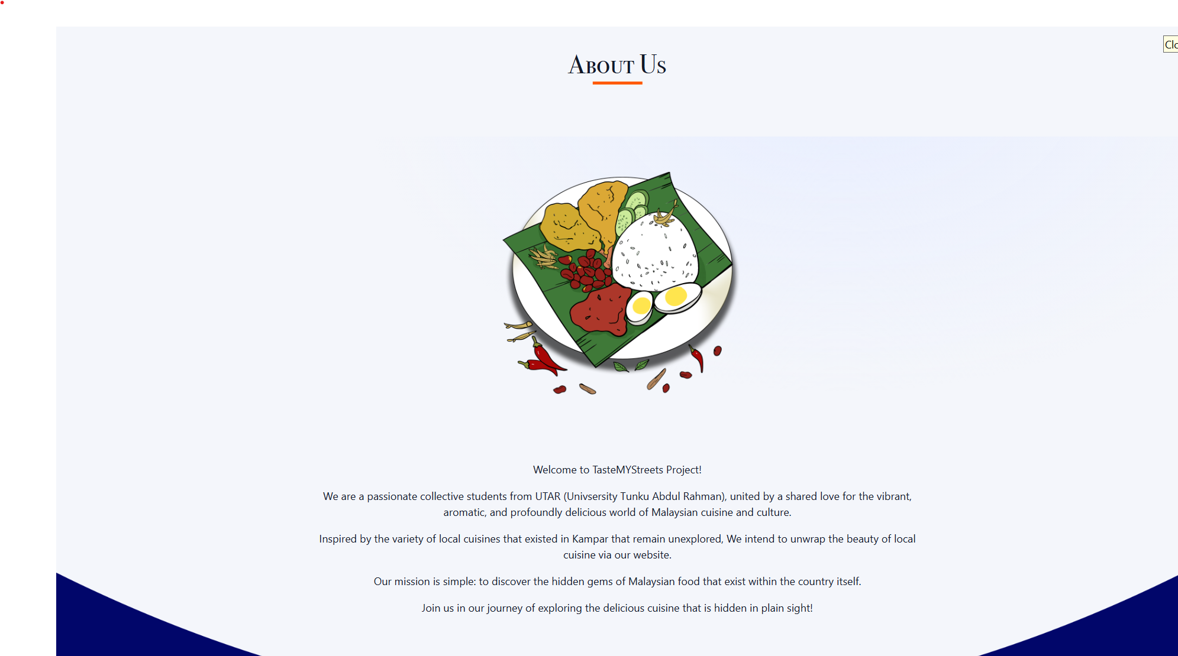

**Contact us page (contact.html)**

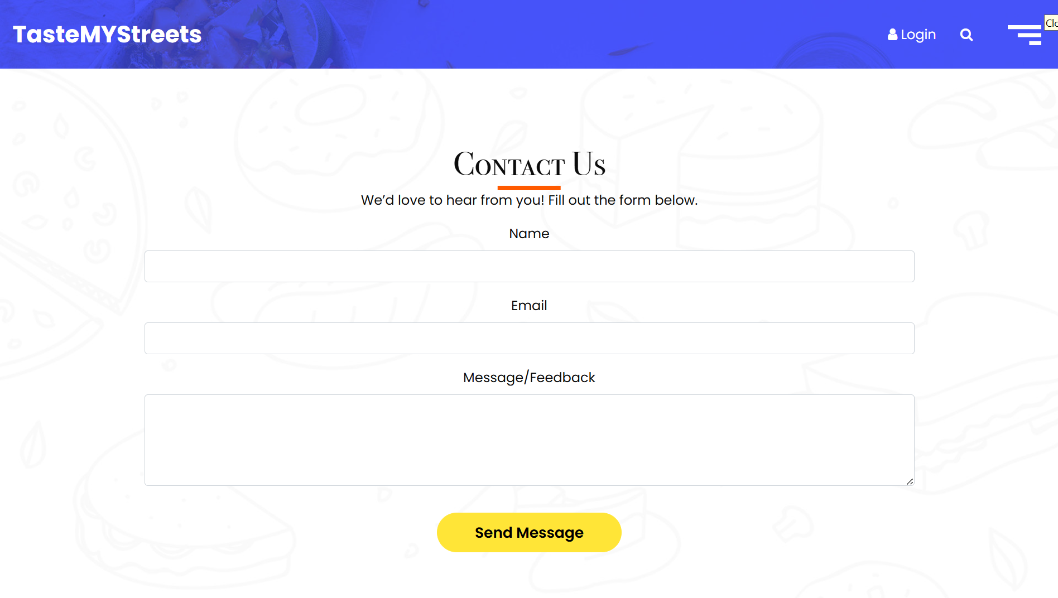

**Discover page (discover.html)**

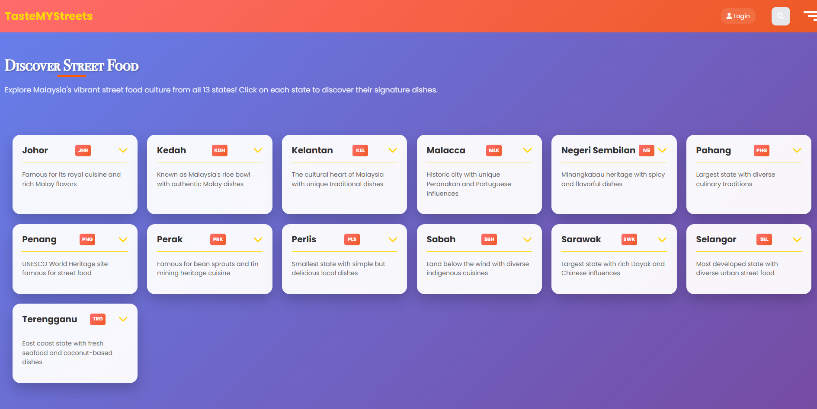

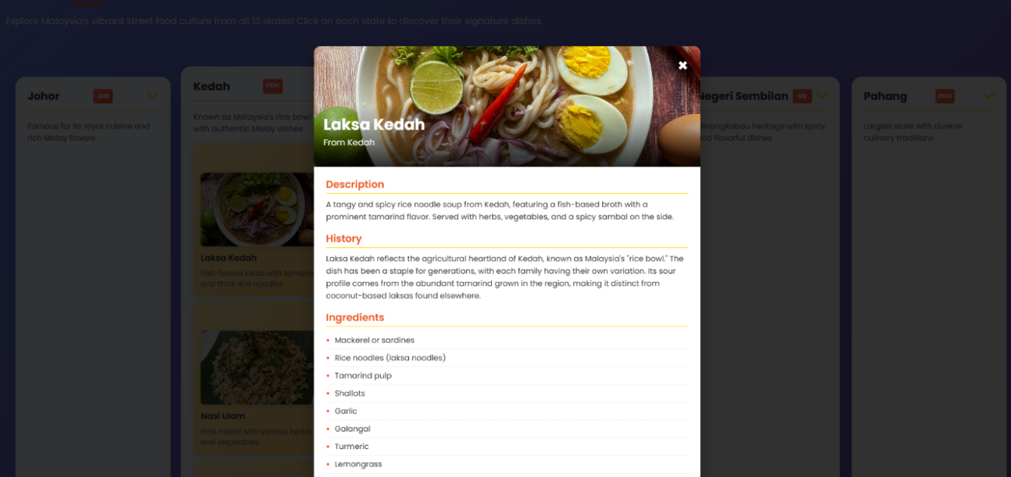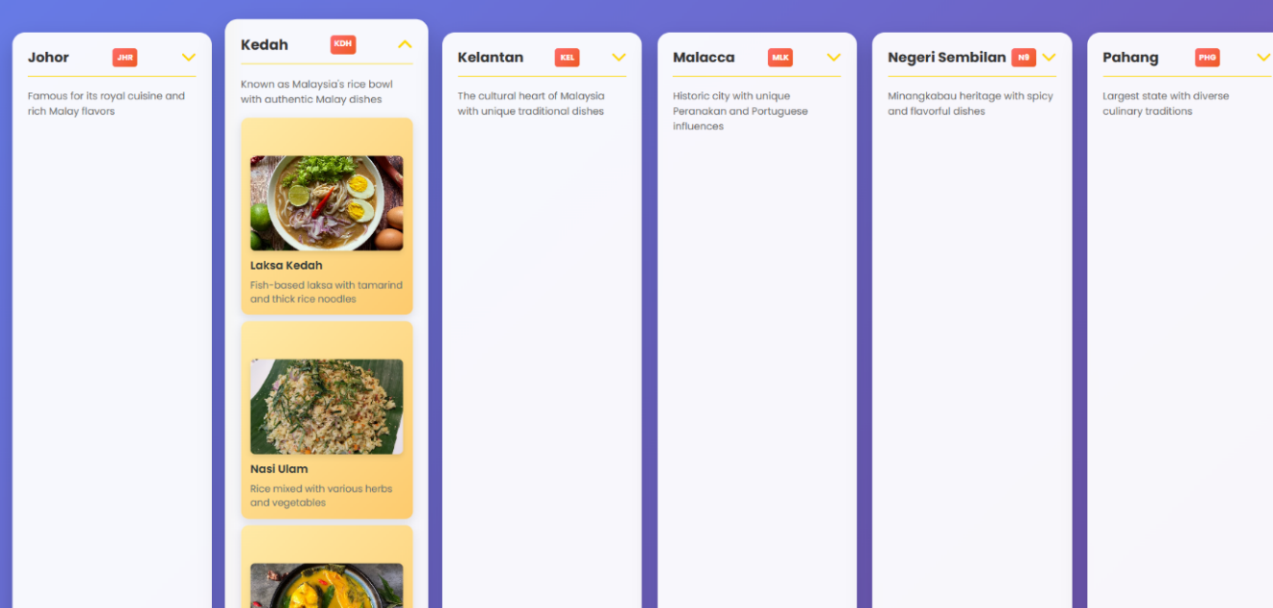

**Top 10 street food page (rank.html)**

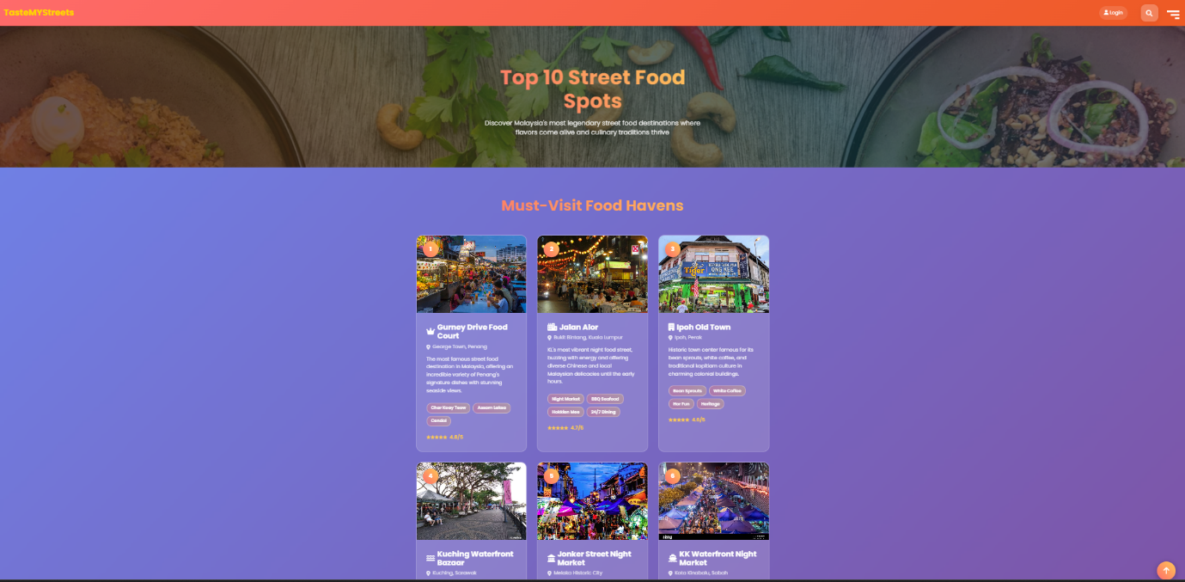

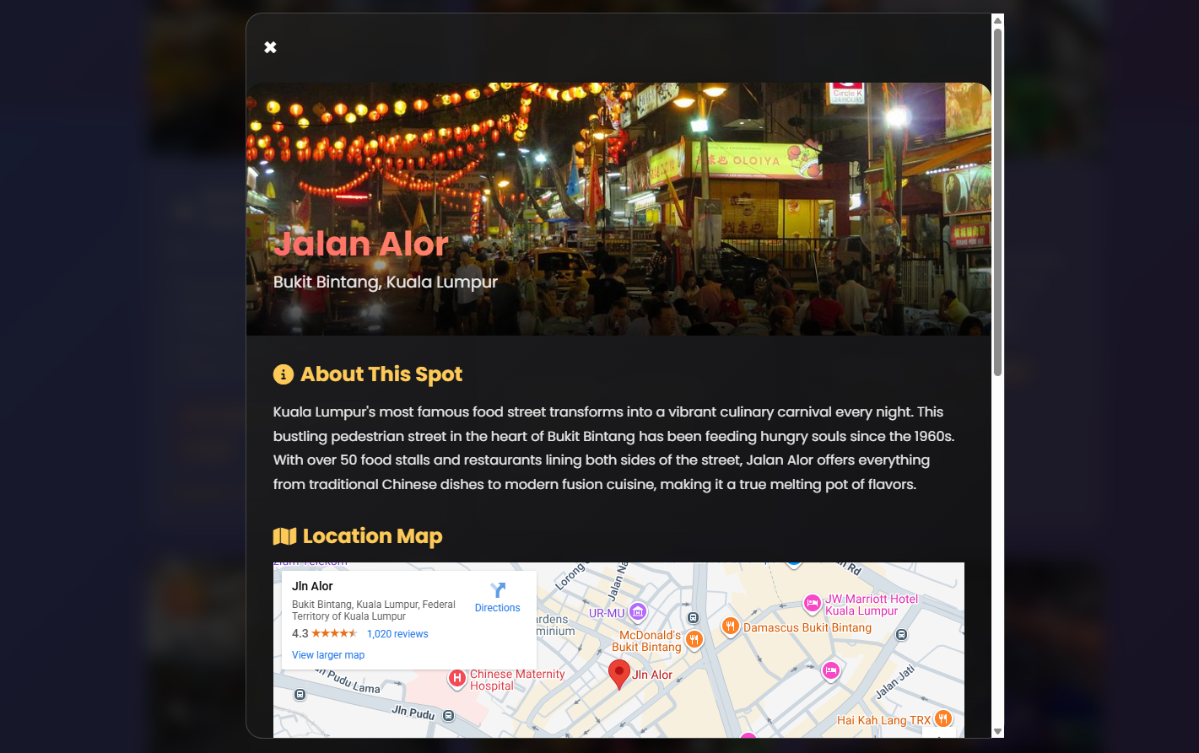

**About page (about.html)**

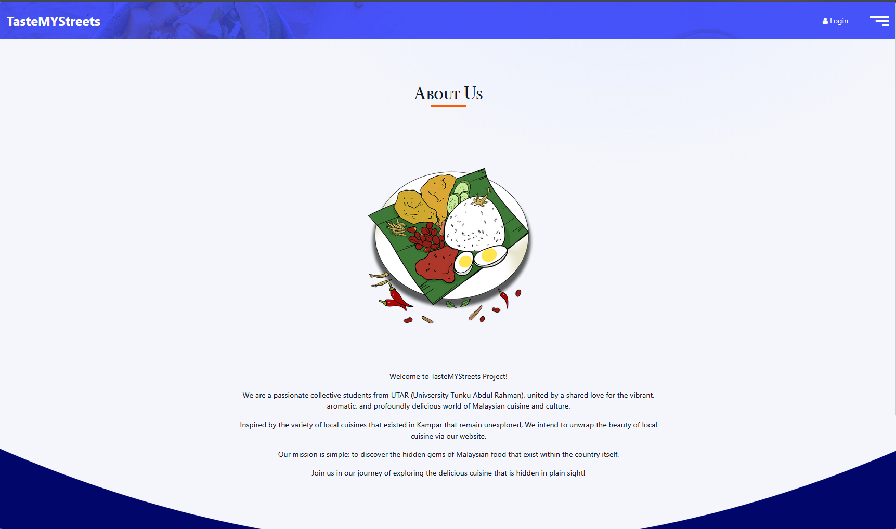

**3.2.9 Quiz page (quiz.html)**

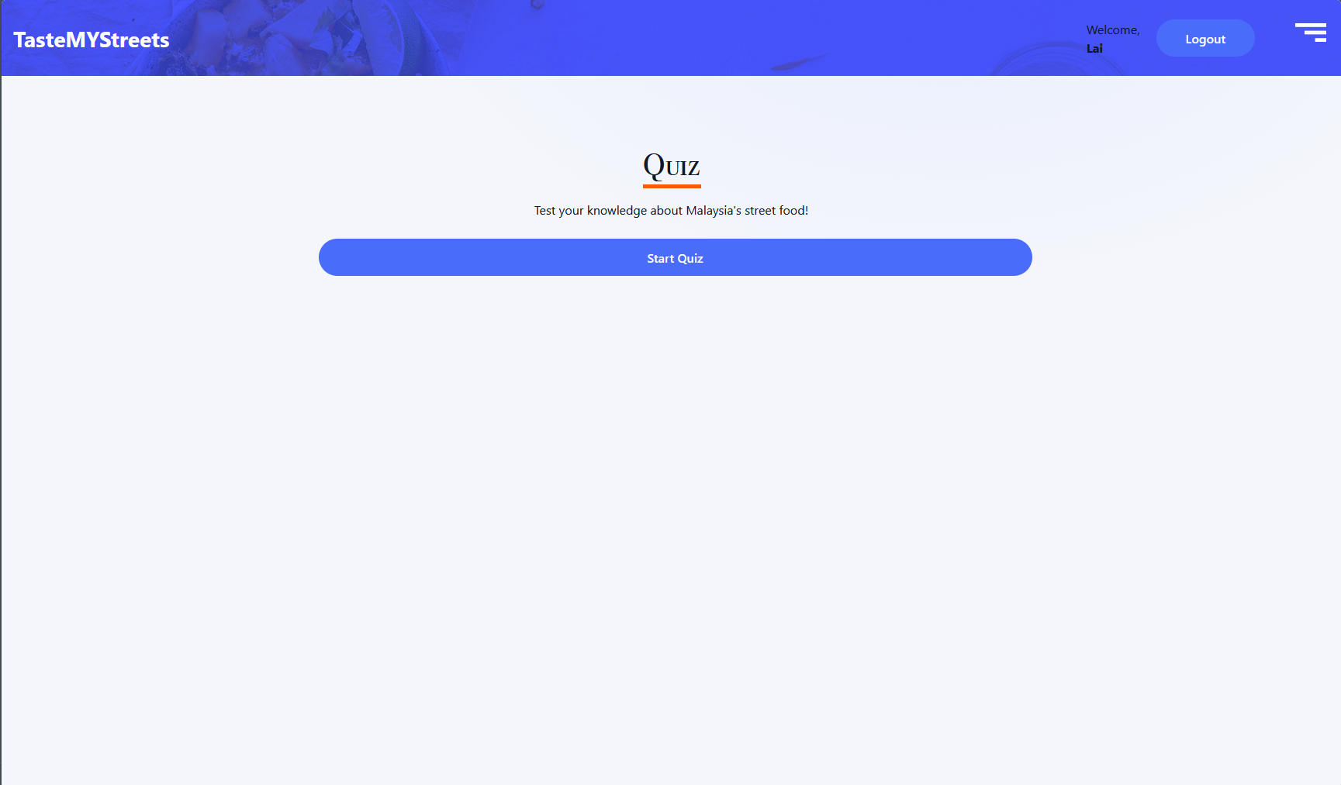

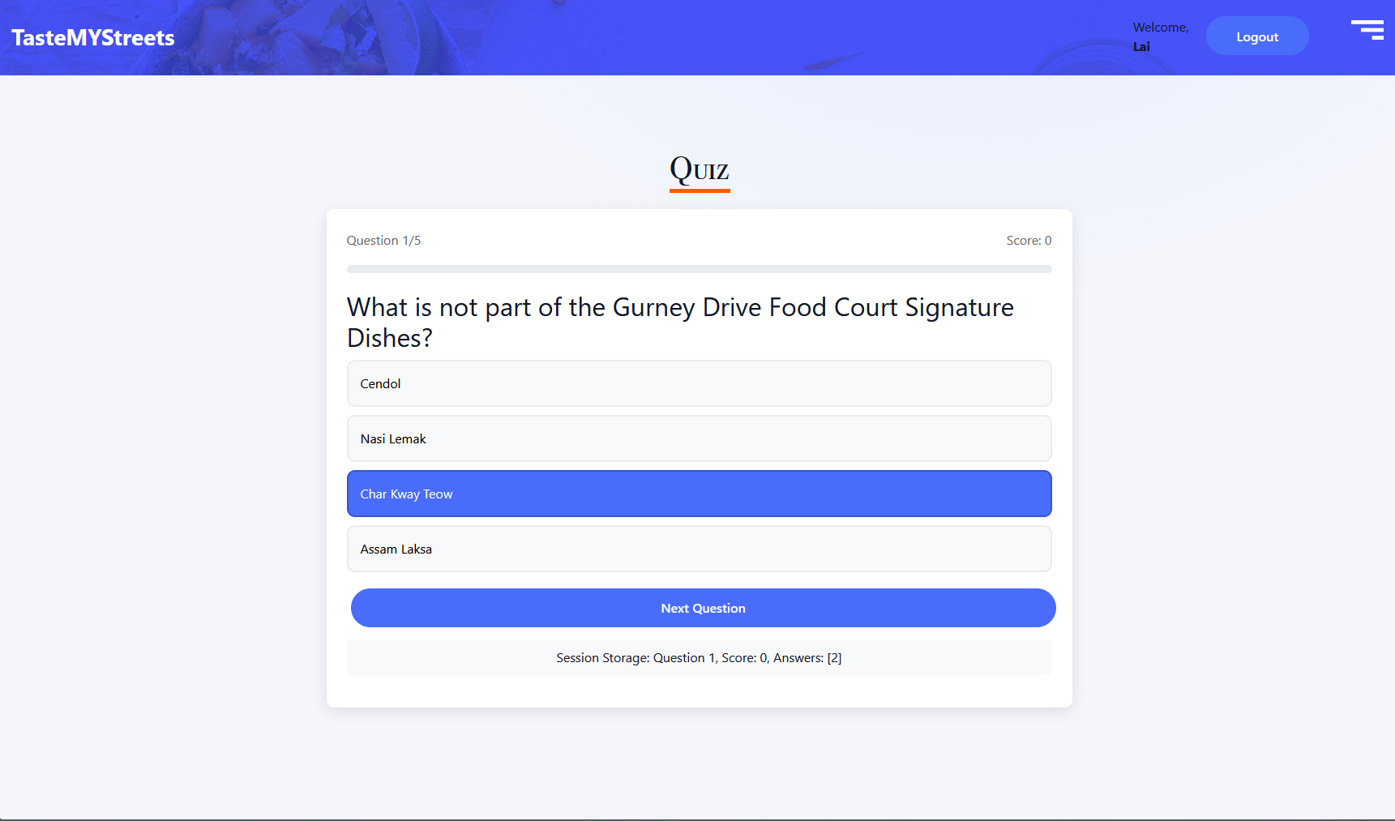

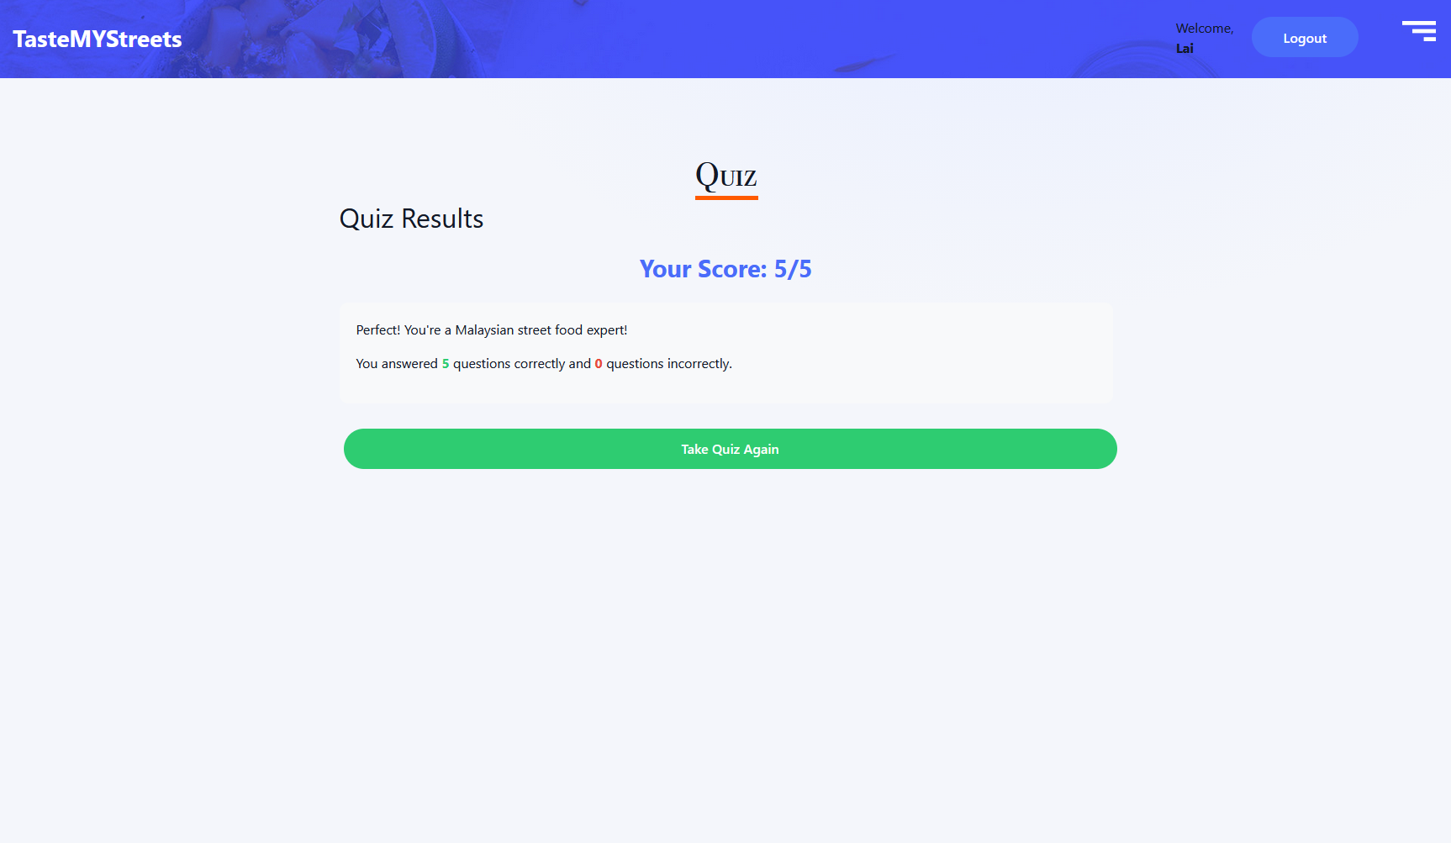

# Site Map

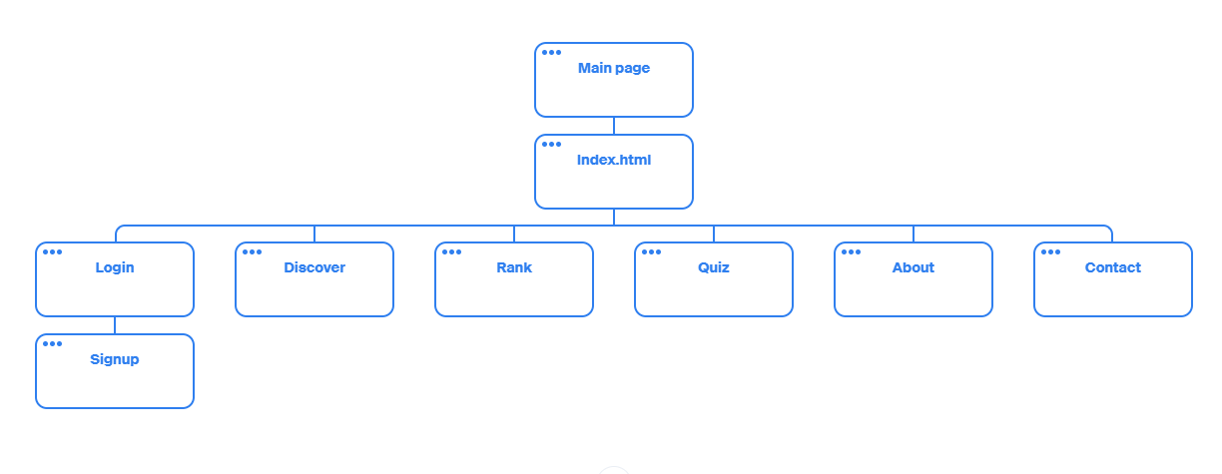

# Evaluation

## Log In (login.html)

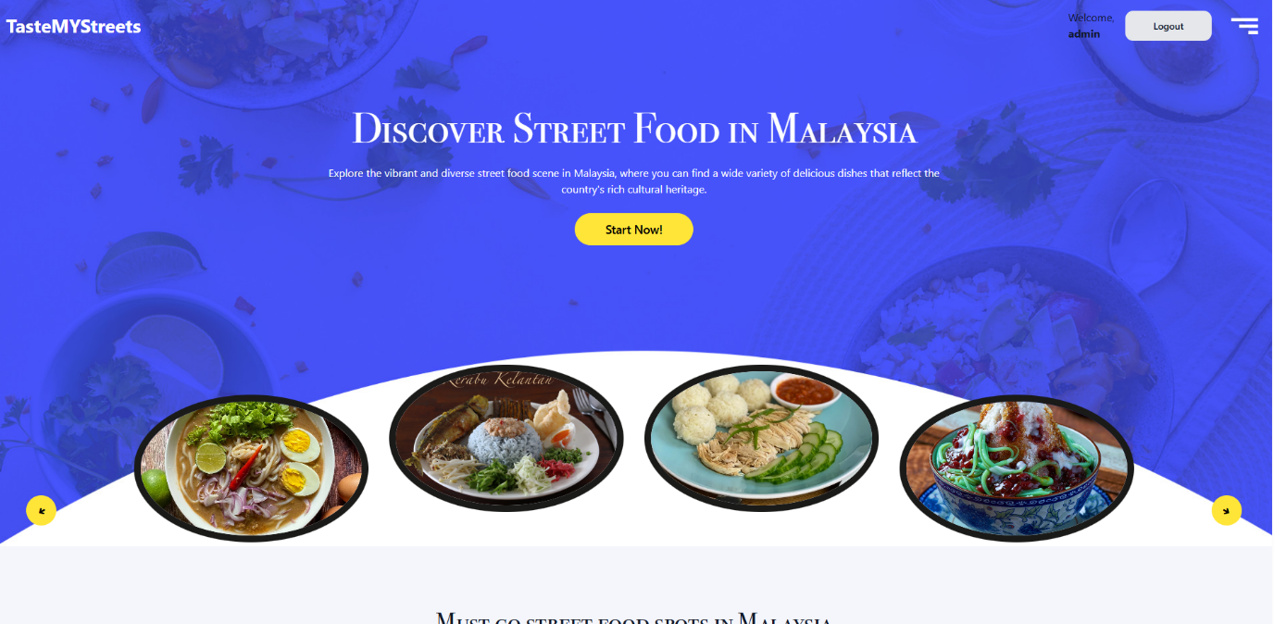

Figure 4.1.1 Logged in Status at top right corner of Header section.

The top-right header on all pages which is Home, Discover Street Food, Top 10 Street Food Spots, Quiz, About, and Contact, is consistency about log in function as when signed in, it reads "Welcome, {username}" with a rounded Logout button, and when signed out, it displays a Login link.

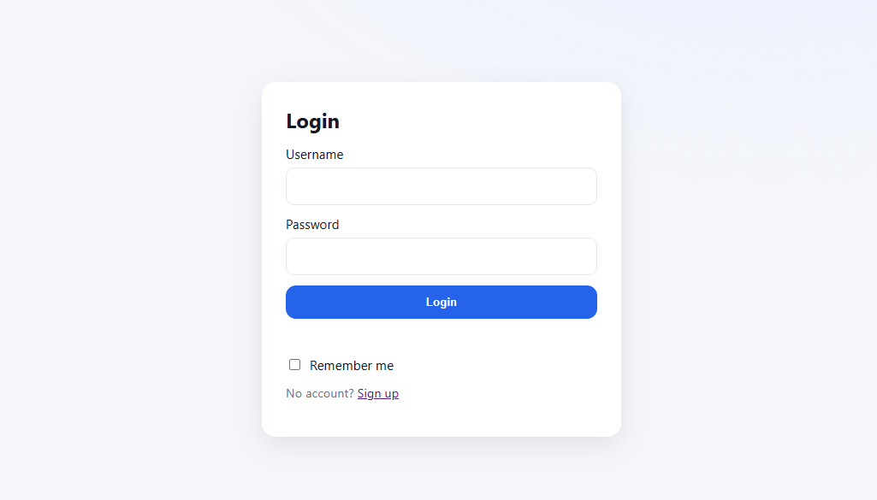

Figure 4.1.2 Log in webpage.

Any protected navigation (marked auth-link) gently redirects unauthenticated users to login.html while retaining the page they requested. To log in, users enter their username and password on login.html and can tick Remember me; if enabled, the username is saved in localStorage (persisted across browser restarts); otherwise, it is saved in sessionStorage (cleared when the tab/window ends). If success, the program shows "Login successful!", saves the username, updates the header, and redirects the user to the original requested page (redirect_after_login) or the home page.

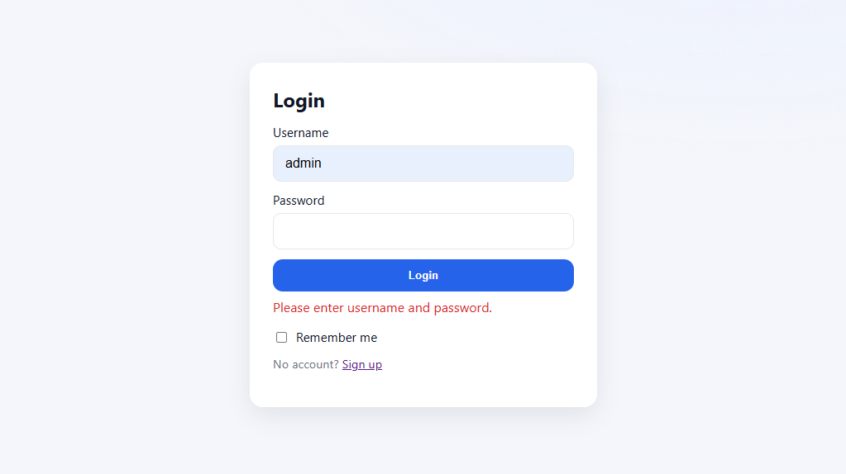

Figure 4.1.3 Clear Feedback for Log In.

Other than that, the form gives clear feedback: missing fields prompt "Please enter username and password." and unknown accounts prompt "Account doesn't exist, please sign up first." Incorrect passwords return the message "Invalid credentials." Once authenticated, the header on all pages adjusts instantly, and previously guarded material becomes available.

## Log Out (logout.html)

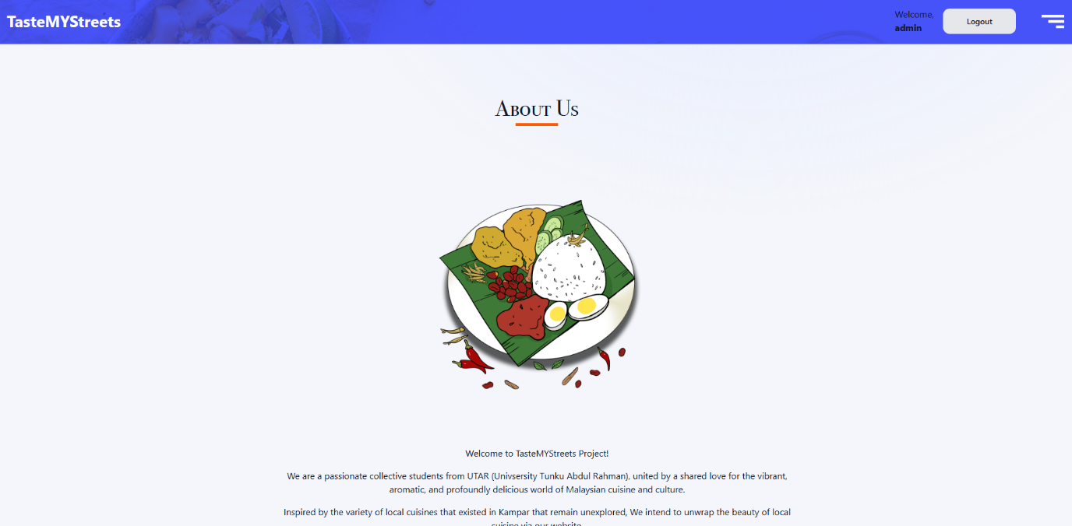

Figure 4.2.1 Log Out available.

Sign-out is available after logged in to the website and available to log out by clicking the Logout button in the shared header.

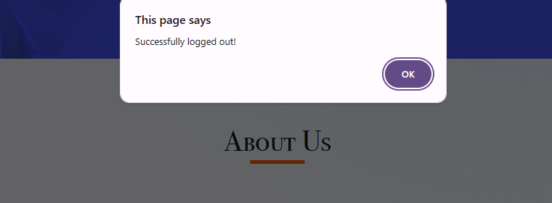

Figure 4.2.2 Prompt appear after Log out.

When clicked, it clears the stored username from sessionStorage and localStorage, displays a confirmation ("Successfully logged out!"), and redirects to logout.html, which displays a success message and a link back to the Login page.

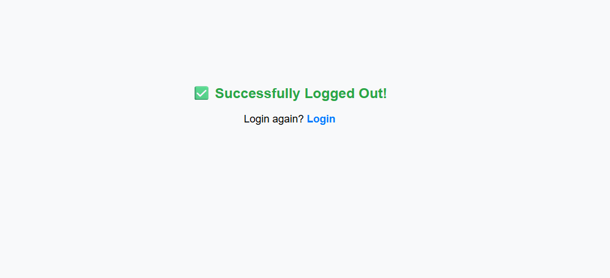

Figure 4.2.3 Logged out page.

After logging out, every page displays the signed-out header (the Login link returns), and any protected links redirect users to the login screen.

## Sign up (signup.html)

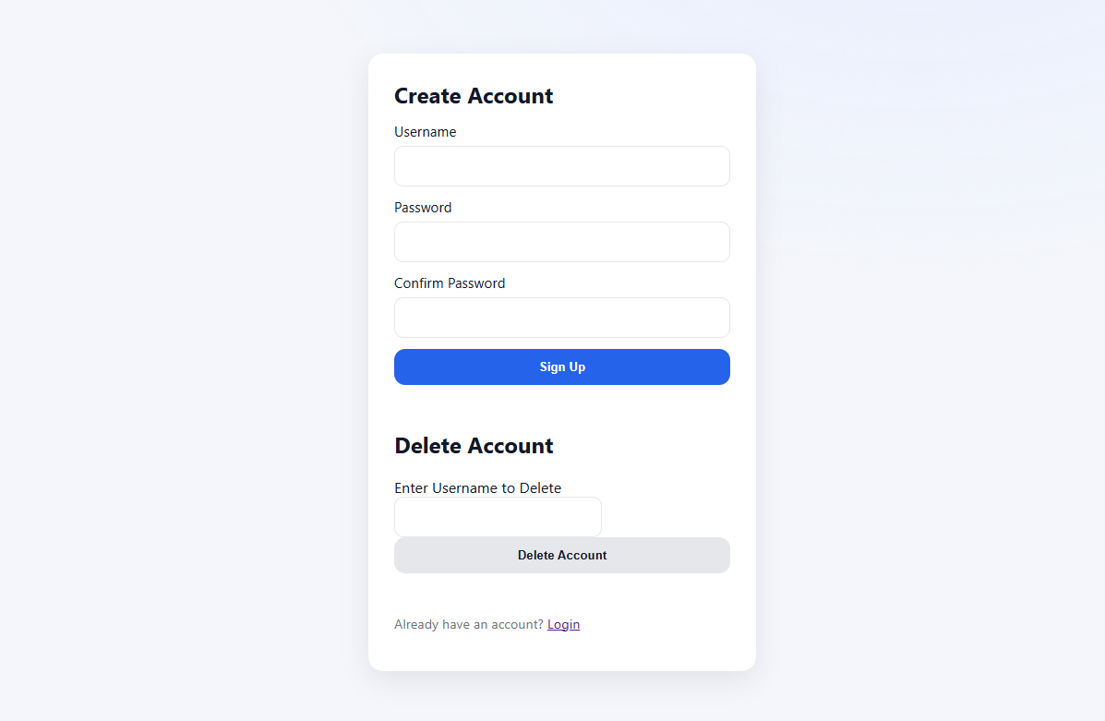

Figure 4.3.1 Sign Up page.

On the Sign-Up page, users can create an account by entering a Username, Password, and Confirm Password before clicking Sign Up. The form will validate input, if any field is left blank, it says "Please fill in all fields."

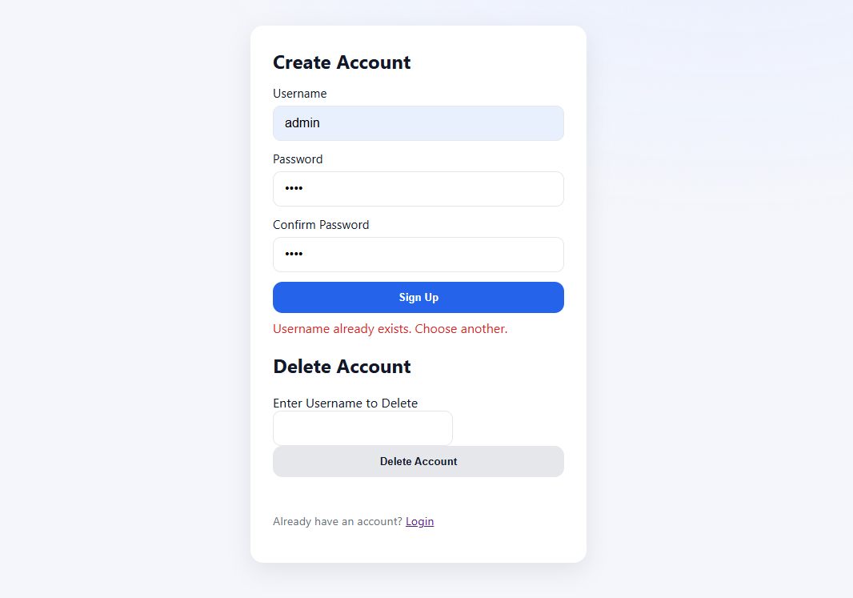

Figure 4.3.2 Sign up page validate input.

If the account entered already exist, it says “Username already exist. Choose another.”, and if the passwords don't match, it says "Passwords do not match." When everything is OK, the new account is added to a demo user list in localStorage, and a message appears: "Signup succeeded! "You can now log in." and go to log in page.

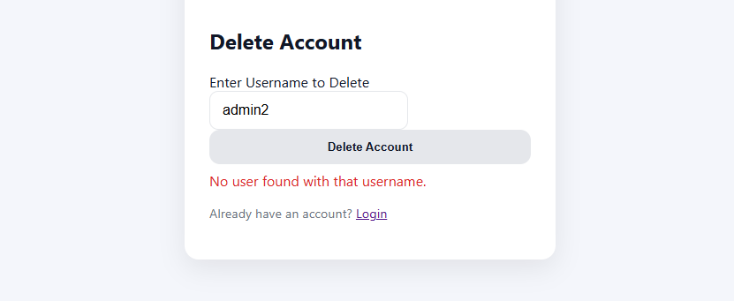

Figure 4.3.3 Delete function Input validation.

The same page also contains a simple Delete Account function. When you enter a username and submit, it is removed from the demo list with the message "Deleted successfully!" If the name does not exist, the program reports "No user found with that username."

After registering, users go through the standard login process. Once verified, all pages (Home, Discover, Top 10, Quiz, About, and Contact) display the same Welcome, {username} / Logout banner, and sign-out is accessible from any page.

## Home page (index.html)

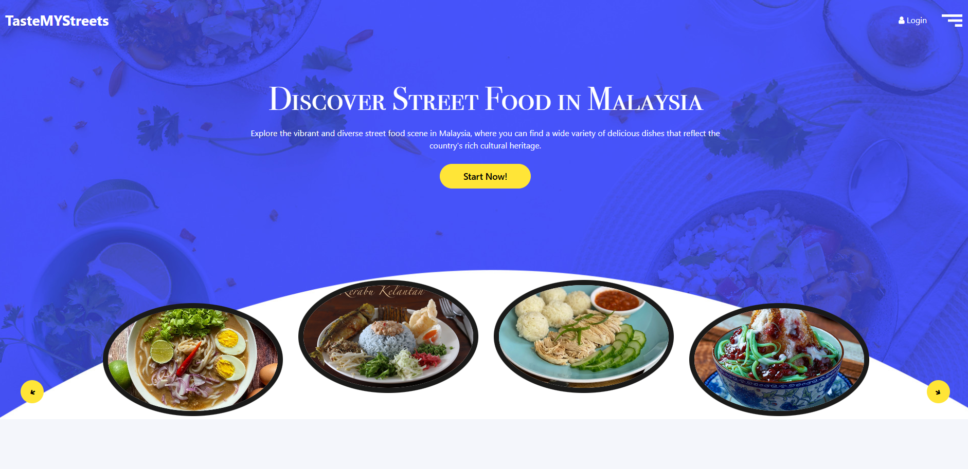

Figure 4.4. 1: Home Page, landing page

The Home page is the landing page and entry point of the website. Users are directed to this page when visiting the website. At top, the navigation bar Giving users quick access to the website feature such as discovering Malaysian street food, viewing the top 10 spots, taking a quiz, and learning more through the About and Contact pages via the menu. Logged in users will be able to see the welcome message, while new visitors can login or sign up through the provided link. By clicking “Start Now” button, users will be directed to the explore street food (requires login). The page also features an image Slider where users can browse images of popular Malaysian street foods.

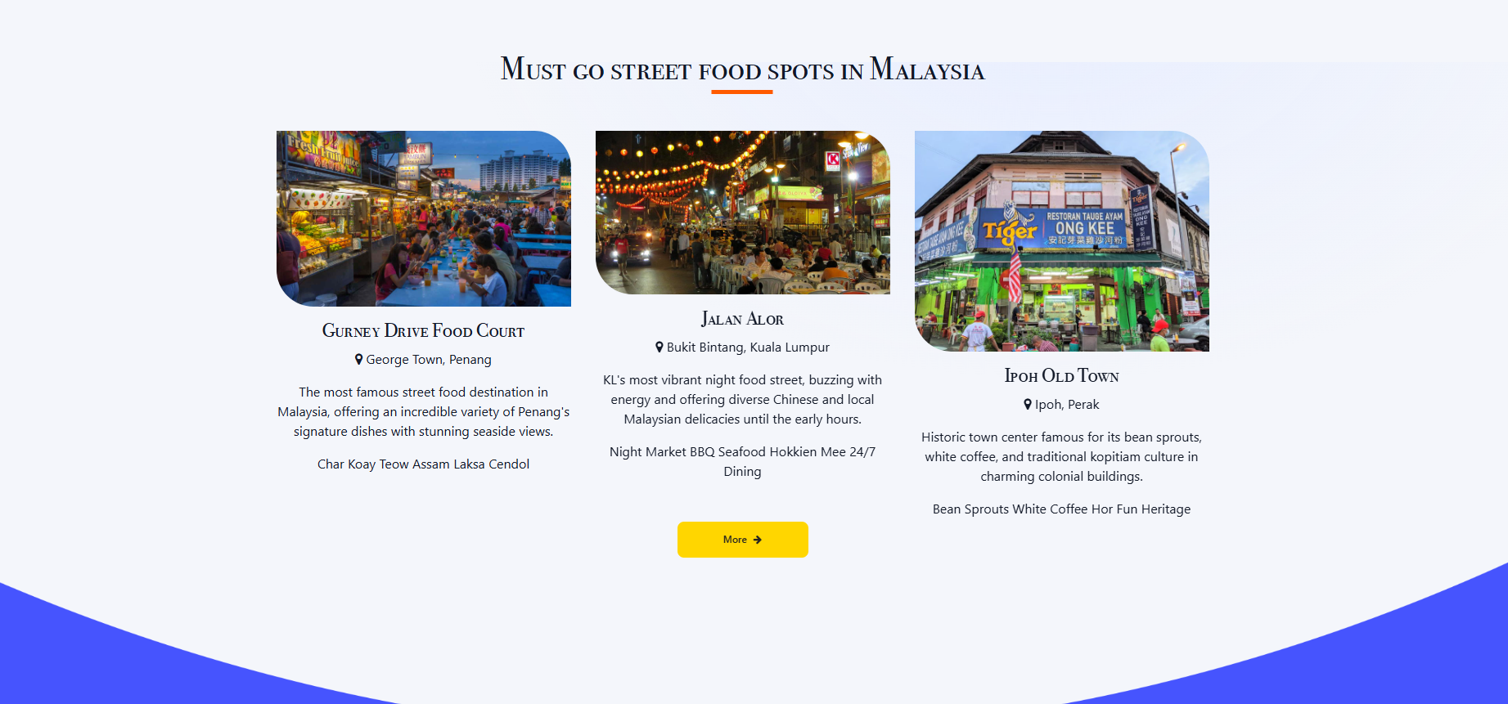

Figure 4.4. 2: Home Page, street food section

Must go street food section of the homepage provides users a click glance of some featured street food spots, user will be directed to “Top 10 street food spot” if they click the more button

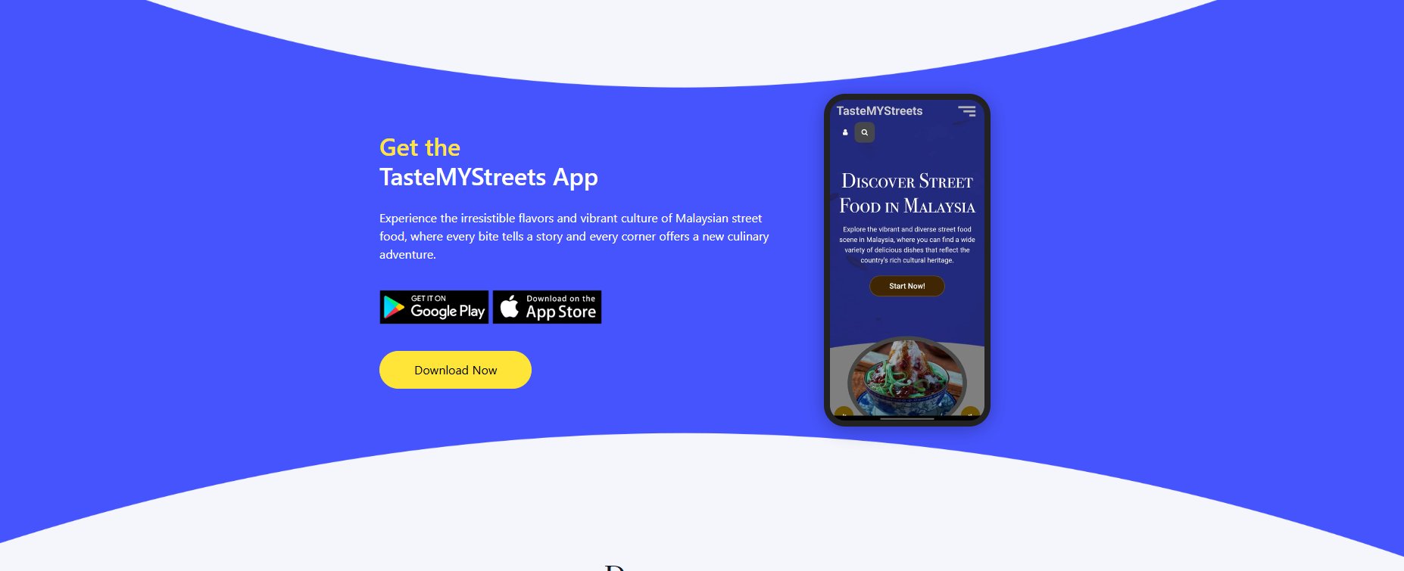

Figure 4.4. 3: Home Page, app promotion section

This section of the homepage features a mobile app promotion for the website, featuring a app preview and screenshot of the app interface

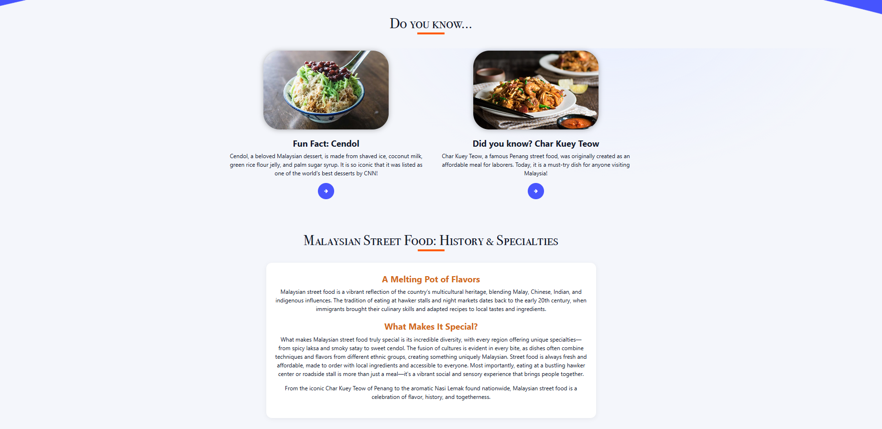

Figure 4.4. 4: Home Page, Fun fact and History Section

This section of the homepage features the fact section, giving street food facts to users, users will be able to click the button to view the food details if interested.

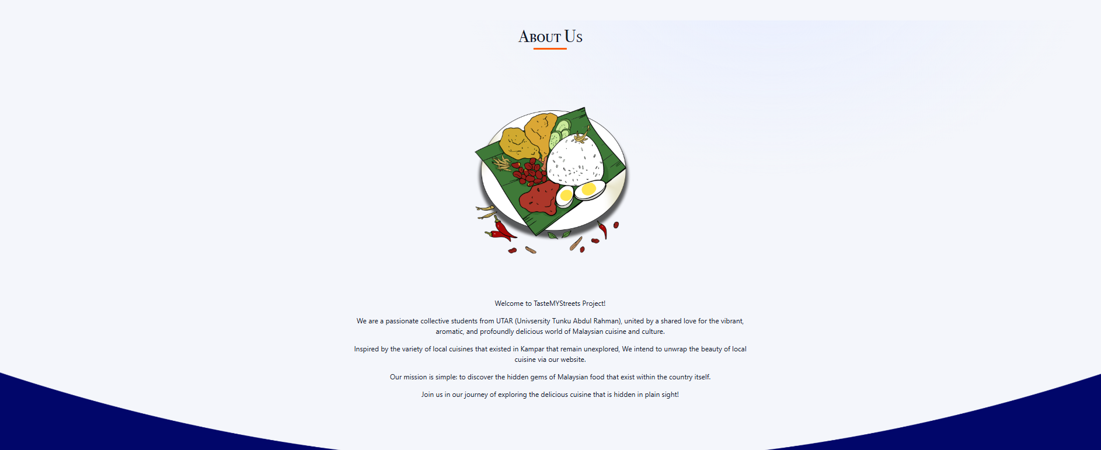

Figure 4.4. 5: Home Page, about us section

This page features the team introduction, giving users info about the vision and aim of our team.

## Contact Page (contact.html)

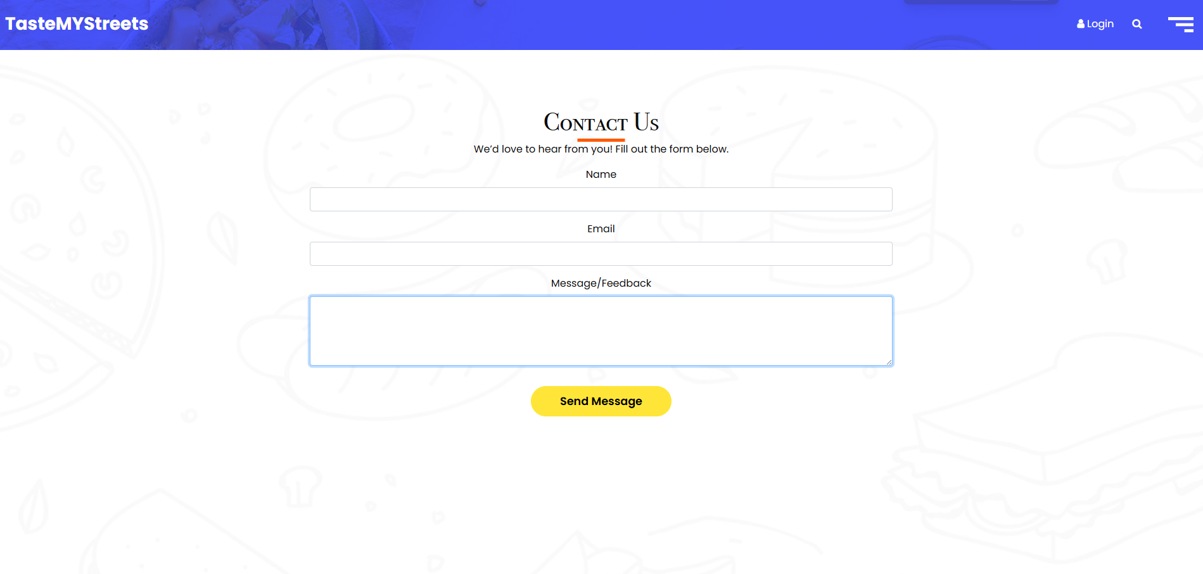

Figure 4.5: Contact Page

The contact page allows users to give feedback or inquires through a simple form. Users can input their name, email and feedback message through the provided fields.

Note: All fields are required. If you miss a field or enter an invalid email, you may see an error message.

## Discover Page (discover.html)

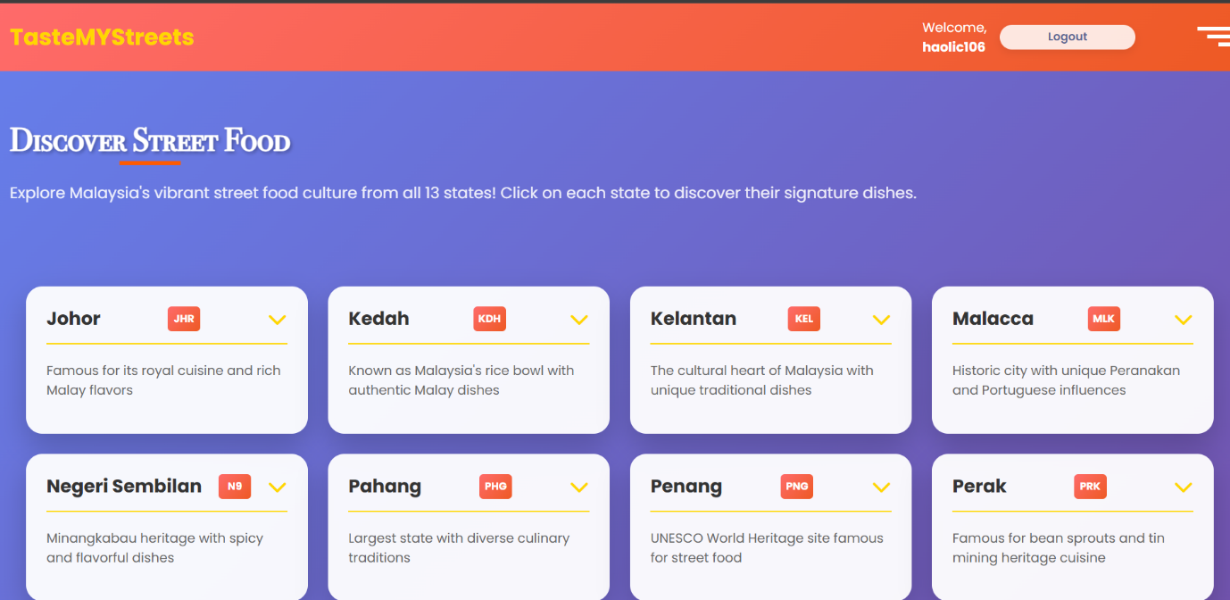

Figure 4.6.1 Discover Street Food Page

This page allow use to browse each 13 states’ street food of Malaysia. The main content is structured into grid of state cards. Each state cards represent a Malaysia state and the state’s name and a summary of the food culture.

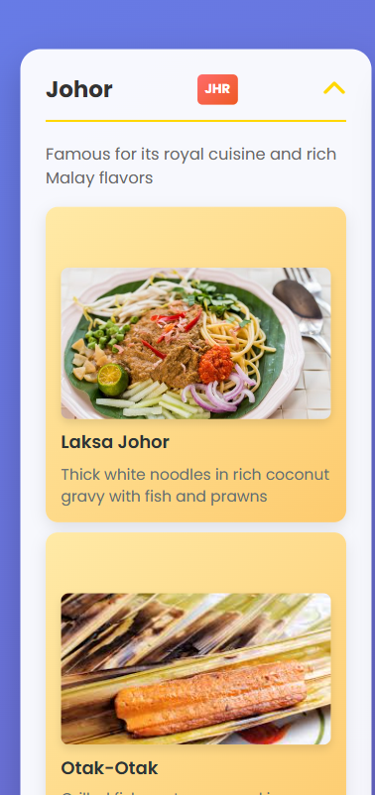

Figure 4.6.2 Expanded State Card

When the state card is clicked, the card will expand and show a list of signature dishes, each with an image, the dish’s name, and a short description.

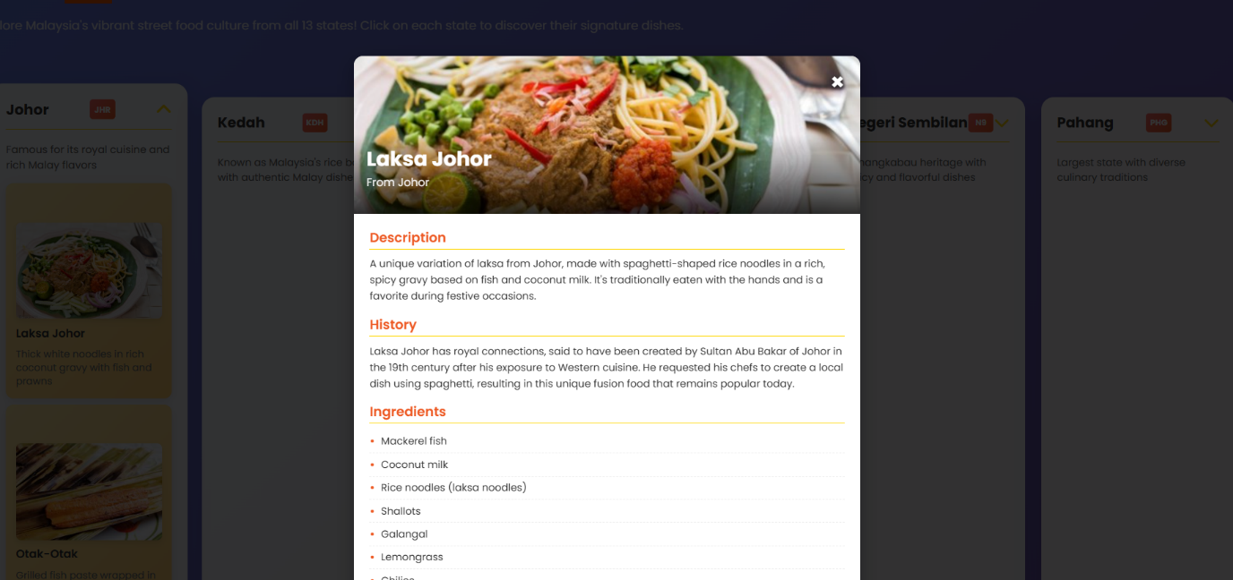

Figure 4.6.3 Modal window after clicking on the food

Clicking on a food item opens a detailed modal window. Inside the modal, users can see a larger image of the dish along with sections covering its description, history, and ingredients.

## Top 10 Street Food Spot Page (rank.html)

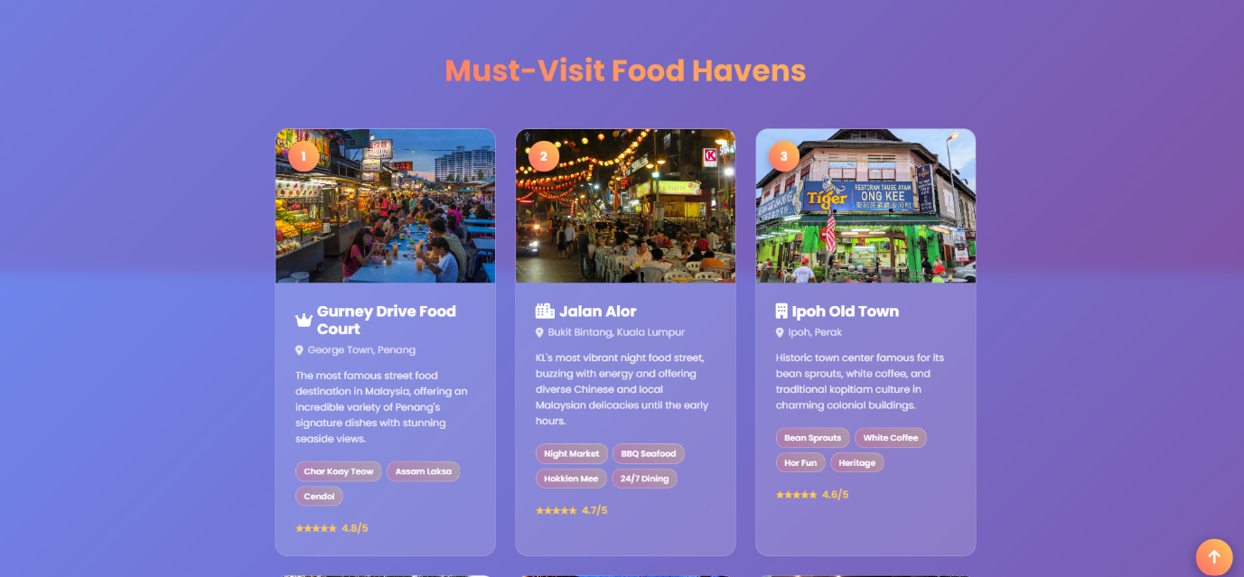

Figure 4.6.1 Top 10 Malaysian Street Food Page

This page highlights the top ten food spots in Malaysia. Each spot is displayed in a visually engaging card format, and each card is clickable, it is showing the ranking number, a picture, the location, a short description, the must-try dishes, and the ratings.

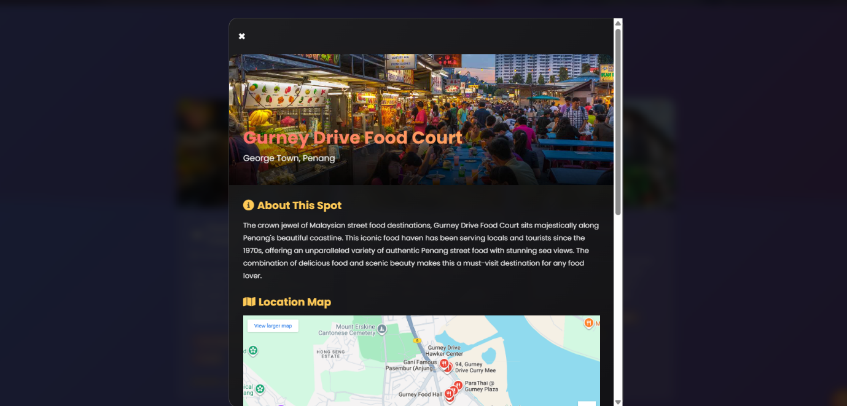Figure 4.6.2 Expanded spot card

When the card is expanded, it opens a detailed modal window, where users can find more information such as an about section, a location map, must-try dishes, operating hours, insider tips, and directions.

## About Page (about.html)



Figure 4.8. 1: About us Page

This page is used for showing the user our mission, vision and our end goal for this website. It is to allow user for understanding what we as a group are working towards and trying to achieve.

## Quiz Page (quiz.html)

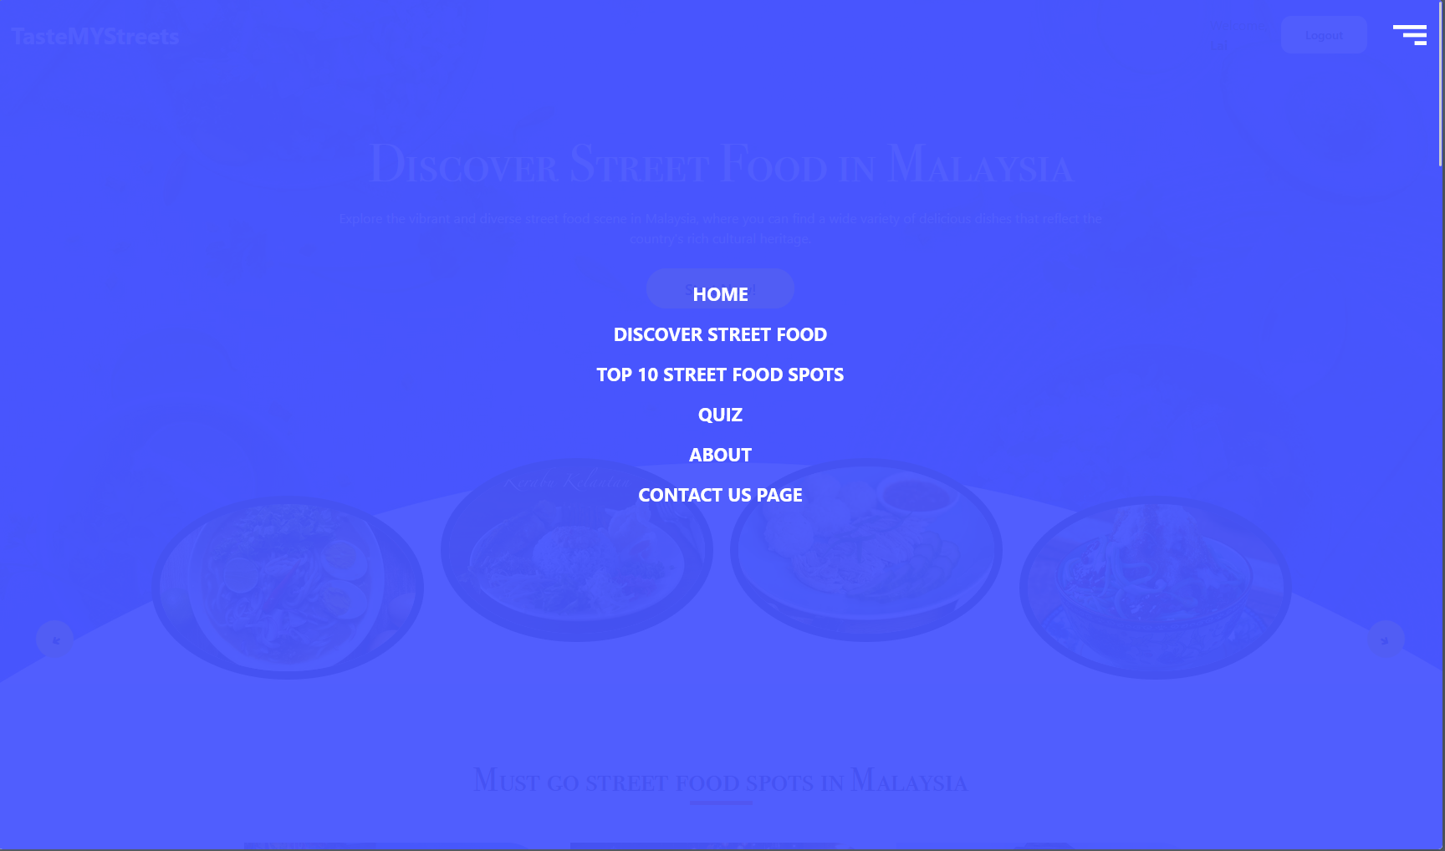

Figure 4.9. 1: Quiz Page (1)

The quiz webpage is accessible from the “Quiz” option in sub-menu from the home page (index.html).



Figure 4.9. 2: Quiz Page (2)

The user is then redirected to the webpage above (quiz.html). To start the quiz feature, user must click onto the “Start Quiz” Button displays in Blue colour.



Figure 4.9. 3: Quiz Page (3)

Upon clicking the button, the quiz interface will show up along with the question itself, 4 buttons that can be selected as answers and a line that indicates the status for session storage. When the user selects any one of the answers presented, a “Next Question” button will appear under the answer’s options. When the user presses the “Next Question” button, the quiz interface will update to a new question with a new set of 4 answers options while the previous answer selected and the correct scores are sent to session storage as part of an array and being recorded there. This process will be continued until the question set is completed.



Figure 4.9. 4: Quiz Page (4)

After the question set is completed, the page will present the result screen with the total scores and how many correct answers and incorrect answers that the user has answered. These data are taken off from session storage and being displayed onto the screen while session storage will be reset for future quiz attempts.